GOVERNMENT OF JAMAICA

[Place name of Ministry here]

STRATEGIC BUSINESS PLAN
2020/2021 – 2023/2024

[This Strategic Business Planning Template serves as the required standard for preparing the
Government of Jamaica’s Strategic Plans for Ministries, in accordance with the
Performance Monitoring and Evaluation System (PMES). The Template has been revised to ensure stronger
alignment to the principles of results-based management and ensure conformity to the
Medium Term Results Based Budgeting (MTRBB) requirements.]

[All instructions are in italics and bracketed and should be deleted from the finalised Ministry Business Plan before submission. The footer on each page must either be deleted, or edited to represent the Ministry. Pages, except appendices, must be numbered and reflected in the Table of Contents accordingly. The instructional sheets preceding the appendices are also to be deleted.]
[The use of pictures and/or diagrams is optional, and if used, should be done so sparingly.]

[Please note that references relating to the Ministry of Industry, Commerce, Agriculture and Fisheries
are used only as illustrations to help guide preparation.]

DOCUMENT APPROVAL AND SIGN OFF

This document has been approved as the official Strategic Business Plan and Budget of the Ministry of Industry, Commerce, Agriculture and Fisheries for the four-year period 2020/2021 – 2023/2024. The Strategic Business Plan and Budget of the Ministry has been prepared in consideration of the various relevant policies, legislation and other mandates for which the Ministry is responsible.

Prepared by | Signature | Date
_________________________________  [Insert Name]  ________________________________  [Insert Title] | _____________________ | _____________
________________________________
[Insert Department]

Approved by | Signature | Date
________________________________  [Insert Name]  Permanent Secretary | ______________________ | _____________

TABLE OF CONTENTS

Honourable Minister’s Message 5
Permanent Secretary’s Message 6
Accountability Statement 7
1.0 Executive Summary 8
1.1 Overview 8
1.2 Vision, Mission, Values and Mandate 11
1.3 Situational Analysis 12
1.4 Programmes and Sub-Programmes 13
1.5 Programme Objectives 14
2.0 Sector Highlights 19
3.0 Ministry’s Current Performance 20
4.0 Performance Improvement Plan 22
5.0 Ministry’s Strategy Map 25
6.0 Programme Activity Architecture 27
7.0 Programme Implementation 29
8.0 Medium Term Financial Resource Plan 35
9.0 Human Resources Capacity Plan 37
10.0 Portfolio Entities Medium Term Implementation Plan 38
11.0 List of Public Sector Enterprises (Self-Financed) 44

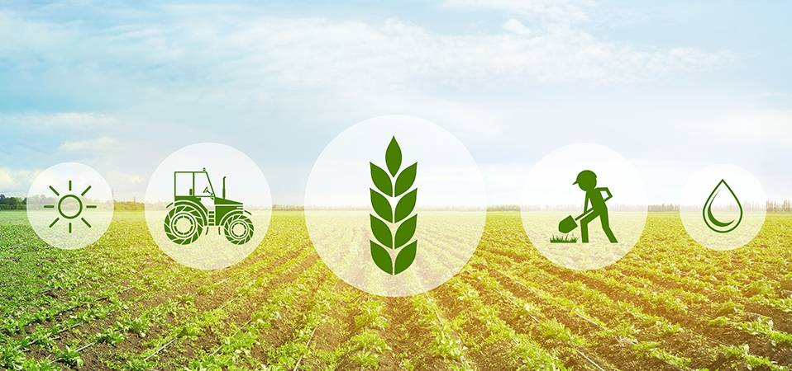

HONOURABLE MINISTER’S MESSAGE
[Message should include the reaffirmation of national strategies and direction of the Ministry, and commitment statement to the strategic business planning process. Message must be signed by the Honourable Minister.]

PERMANENT SECRETARY’S MESSAGE
[Message should include the Ministry’s key initiatives that are being implemented; and their alignment to national goals and outcomes, and the GOJ strategic priorities. Reference should also be made, where necessary, to the global/ international context in which the Ministry operates.]
[Message must be signed by the Permanent Secretary.]

ACCOUNTABILITY STATEMENT
[See example of an Accountability Statement below. The Accountability Statement developed by each Ministry must be signed by the Permanent Secretary. However, in the case of the Ministry of Finance, the Statement must be signed by both the Honourable Minister and the Financial Secretary].

This Strategic Business Plan for the next four years, commencing April 1, 2020 was prepared under my direction in accordance with the policy directives outlined by the Government of Jamaica, and the authority delegated to me under Section 16 of the Financial Administration and Audit (FAA) Act. The Plan outlines the Ministry’s strategies that contribute to the achievement of the Government’s agenda, and specifically, the programmes for which appropriate monitoring and evaluation mechanisms are being deployed to ensure their timely and cost-effective implementation.

The Ministry’s priorities outlined in this Business Plan were identified in context of the Government’s medium-term priorities and fiscal targets. I am, therefore, committed to achieving the planned results laid out in this Business Plan.

[Signature]
Permanent Secretary
[Ministry of Industry, Commerce, Agriculture and Fisheries]

1.0 EXECUTIVE SUMMARY
[Provide a brief overview of the profile and purpose of the Ministry, and its areas of responsibilities. Outline the various challenges faced by the sector and the plans that are being implemented and/or being proposed to address them. Directly below is an example].

1.1 OVERVIEW

The Ministry of Industry, Commerce, Agriculture and Fisheries (MICAF) is responsible for driving the production of primary agricultural produce, livestock and fisheries to widen the supply chains, and to integrate production up the value chain. This will facilitate public value and full commercialization of outputs of the agriculture, manufacturing, and services sectors. Of equal importance, the Ministry is one of the pillars that supports business development and trade facilitation which contributes to sustainable economic growth.

The Ministry oversees a portfolio of thirty-one (31) divisions, twenty-two (22) portfolio bodies that are partially/fully funded through the consolidated fund and eighteen (18) statutory bodies, which provide important services to the agriculture, fisheries, manufacturing and service sectors as well as to organizations that work to promote growth in these sectors.

Within this context, the Ministry is regarded as one of the most strategically configured and positioned Government of Jamaica entities. This Ministry and its agencies represent a major component of the country’s economy and have responsibility for over 30% of the gross domestic product and are responsible for employing 40.7% of the total labour force. Against this background, MICAF approached the task of developing this Plan using its corporate strategy “Building synergies for inclusive and sustainable growth”, with a view of realizing the organizational synergies that are necessary to create the enabling environmental to allow the appropriate mix of policies, legislation, human and capital resources and services to yield the type and levels of economic growth in a sustained manner for the country.

Further, in keeping with the National Development Plan – VISION 2030, the strategic roadmap for Jamaica to achieve developed status by 2030, MICAF seeks to play its part in achieving this goal by abiding to a strategic trajectory geared towards addressing its strategic priorities. The Ministry’s policies, programmes and projects are also guided by the Government of Jamaica’s Strategic Priority – Inclusive Sustainable Economic Growth and Job Creation.

This Strategic Business Plan identifies and describes the priority policies and actions to be pursued in order to build resilience and viability of the productive sectors. It is the road map to managing our programmes, projects and processes to engender transformational growth, job creation and a diversified economy. It is in this view, MICAF has factored in the impact of adverse weather on the agricultural sector and the economy in our planning. Our response is to pursue climate smart policies and programmes geared towards sustainable production and consistent level of support for the economy. Furthermore, efforts will continue to facilitate and promote the development of the Micro, Small and Medium sized Enterprises (MSMEs). The development of this sector is critical to the transformational growth envisioned for all sectors of the economy viz manufacturing, agriculture, logistics offshore services and tourism. These linkages must be encouraged. In this regard, programmes will be developed to facilitate the integration of MSME’s into the global supply and value chains.

The medium-term period will also see focus placed on the large tracts of former arable sugar cane lands on the southern plains of Clarendon and St. Catherine, which have become available for alternative production and will be used to support the expansion in agricultural production and productivity through the development of Agro-Economic Zones. This will diversify and expand the agricultural production under the Southern Plains Agricultural Development Programme (SPADP) and is expected to yield more opportunities to transform the agricultural sector and bolster its contribution to the national economy. The development of new and emerging industries such as cannabis, bamboo, castor beans and capture fisheries will also be pursued to enable further diversification towards internationally competitive, sustainable and inclusive agro-enterprises.

The strategies outlined to deliver programmes are seeking, to not just, build out productive capacities, but to consolidate the gains made. Additionally, every opportunity to ensure adoption and application of new technology; promotion and facilitation of innovation; and application of best practices for optimal production and efficiency gains will be engaged and pursued. To this end, as the Ministry embarks on strategizing for the new medium-term period, there is also a strong focus on identifying opportunities for value creation, supported by a policy, regulatory and institutional framework that enables agricultural value chain to become stronger in order to drive the improvement being envisaged within the sector. In tandem, opportunities will be created for increased private sector engagement, including the formation of public-private partnerships for developing synergies. Other critical areas include enabling greater access to credit for participants along the value chain, support for innovation and technology for developing competitive value chains, provision of access to value-responsive markets, provision of mechanisms to allow for reduction in transaction costs, and the provision of timely and reliable information to make evidence-based decisions.

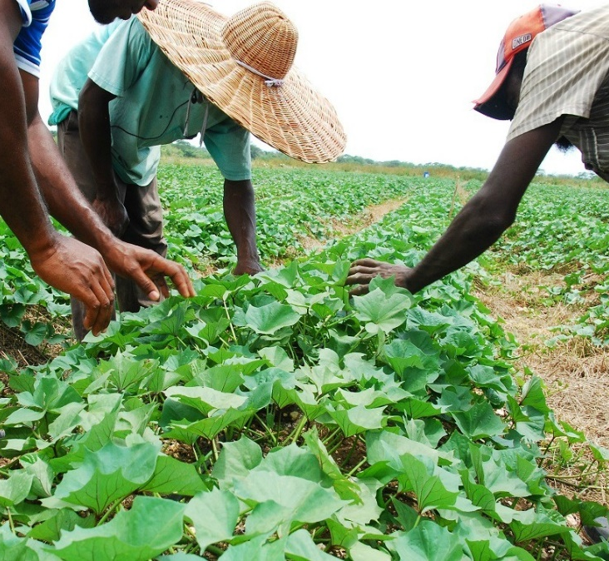

1.2 VISION, MISSION, VALUES & MANDATE
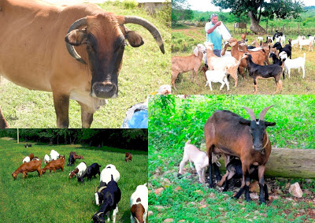
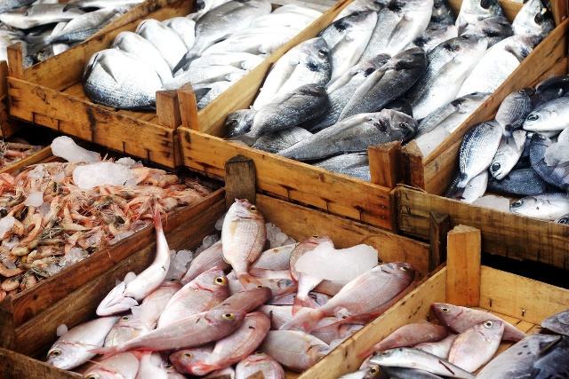
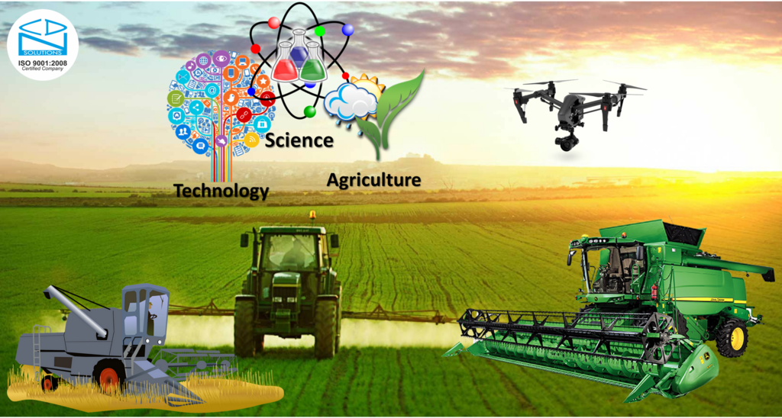
MANDATE
The mandate of MICAF is:
- To drive the production of primary agricultural produce, livestock and fisheries to widen the supply chain and integrate production up the value chain.
- To foster a lucrative MSME sector that drives productivity and boost job creation.
- To increase the application of technology, innovation, R&D to agricultural production, MSMEs and fisheries.
- To secure a modern and efficient business & trade economy within a framework of accountability and good governance.

SUPPORTING GOJ MEDIUM-TERM STRATEGIC PRIORITIES
[State the GOJ Medium-term Strategic Priorities to which the Ministry’s programmes are aligned]
- Inclusive Sustainable Economic Growth and Job Creation

STRATEGIC OBJECTIVES
[Outline the strategic objectives of the Ministry]
- To increase, by 10% annually, the output of agriculture and fisheries resources, including value-added production.
- To increase, by 20%, the application of appropriate technology by Jamaican MSMEs through research, development & innovation.
- To facilitate the development of five (5) new Jamaican products with all-inclusive marketing frameworks by 2024
- To facilitate, through the use of standards and conformity assessments, an increase in access to markets for Jamaican products.

Vision

[The Vision must indicate the long-term desired change to the state of the Ministry, as a result of its programmes.]

For example: The Vision of MICAF is:

“By 2030, MICAF is recognised as the leading government Ministry that drives economic development.”

Mission Statement

[The Mission must indicate the overall purpose for which the Ministry currently exists, whilst capturing the core business of the Ministry as well as that of its portfolio entities.]

For example: The Mission of MICAF is:

“To create an enabling environment which grows and sustains industries in agriculture, fisheries, manufacturing and service sectors; and ensure consumer protection while fostering gender equality and social inclusion in all our policies, programmes and projects.”

Core Values

[Indicate the core principles that are important to the Ministry and which will govern its conduct and guide its actions]
Fairness Accountability Integrity
Respect Excellence Stewardship
Transparency

1.3 SITUATIONAL ANALYSIS

[Insert the conclusion from undertaking the situational analysis. This should summarise the current situation vis-a-vis environmental factors, performance gaps, as well as the strategic responses that will be required in order to build on strengths and opportunities, and to minimise weaknesses and threats. This section should lead the reader to identify specific strategies that will be communicated through the programmes of the Ministry].
The situational analysis provides the context and knowledge for planning. A situational analysis describes an organization’s competitive position [agencies and departments etc.], operating and financial condition and general state of internal and external affairs. It is useful when defining the organisation’s capability, competitor, and the customer to determine the crucial steps that the business needs to take within the marketplace.
A combination of tools can be used to conduct the situational analysis. Some of the tools are the SWOT Analysis, PESTEL Analysis and 5C’s [company, competitors, customers, collaborators and climate] Analysis. The tools from the Annex to the Strategic Business Plan should be used to summarise the situational analysis.
Factors to consider when doing a situational analysis

- Product Situation - Determine your current product. You may want to view this definition in parts such as the core product and any secondary or supporting services or products that you sell. Viewing your products and services separately helps determine how each relates to your core clients' needs.

- Competitive Situation - Analyse your main competitors and determine how they compare to your business such as competitive advantages, as applicable.

- Distribution Situation - Review your distribution situation in terms of how you get your products to market, such as through distributors or other intermediaries.

- Environmental Factors - Determine the external and internal environmental factors, which can include economic or sociological factors that impact your business's performance.

- Opportunity and Issue Analysis - Conduct a SWOT analysis to determine any strengths, weaknesses, opportunities, and threats that may affect your organisation and its performance.
NB. Templates [SWOT, PESTEL etc.] should be placed in the Annex to the Strategic Business Plan.

1.4 PROGRAMMES AND SUB-PROGRAMMES

The Ministry’s programmes are being planned and developed with great consideration of the National Development Plan Vision 2030, Jamaica; Medium Term Economic Programme (MTEP); Medium Term Socio-Economic Policy Framework 2018 - 2021 (MTF) and the Medium-Term Results Based Budgeting for Jamaica. With these in mind, the Ministry’s programmes and sub-programmes for the medium term are as indicated to the right.

PRIORITY POLICIES
The Ministry’s programmes and sub-programmes are within the context of the priority policies that the Ministry have highlighted for focus and for which approval is given by Cabinet to implement the Ministry’s initiatives. The policy priorities that inform the development of the Ministry’s programmes over the medium term are:
- Optimisation of National Food Security System
- Strengthening of agro-business and processing
- Value Chain Creation
- Agricultural Investment
- Financing of, and support to the development of, MSMEs business ventures.
- Strengthen MSMEs’ contribution to the Jamaican economy
- Blue Economy and Fisheries
- Consumer & Business Protection

PROGRAMMES & SUB-PROGRAMMES

[List the programmes and sub-programmes of the Ministry, as identified in the Ministry’s Rationalized Programme Budget Structure that were developed during the MTRBB consultation process]

PROGRAMME #1: EXECUTIVE DIRECTION AND ADMINISTRATION
Sub-programme:
- Central Administration
- Policy Planning, Development & Research

PROGRAMME #2: INDUSTRIAL DEVELOPMENT AND REGULATION
Sub-programme:
- Micro, Small and Medium Sized Enterprises Development
- Agro-Industry Development
- Business Protection & Commodity Regulation
- Youth Agriculture and Entrepreneur Development

PROGRAMME #3: AGRICULTURAL PRODUCTION, PRODUCTIVITY & FOOD SECURITY
Sub-programme:
- Agricultural Health and Food Safety
- Fisheries Development
- Extension and Regulatory Services
- Management of Zoos and Gardens

PROGRAMME #4: TRADE PROMOTION AND BUSINESS DEVELOPMENT
Sub-programme:
- Investment Promotion
- Trade Facilitation
- National Quality Infrastructure

PROGRAMME #5: CONSUMER & PUBLIC PROTECTION
Sub-programme:
- Protection of Human Rights
- Regulation of Nuclear Technologies

1.5 PROGRAMME OBJECTIVES

[List all the programmes and sub-programmes of the Ministry (as outlined on the previous page), their objectives and what the programmes encompass. This section should be aligned to the programmes and sub-programmes in the Ministry’s Rationalized Programme Budget Structure, constituted as part of the MTRBB Process]. See format below, with an example.]

PROGRAMME NAME: [Insert name of programme]

Objective(s): | [State what results the programme aims to achieve in the medium term. As far as practicable, the objective should be measureable, specific, and time-bound]
Description & Context | [Provide the description and context of the programme, to include any strategic issue that it seeks to address, within the national context]

Sub-programme | [State what results the sub-programme aims to achieve in the medium term. As far as practicable, the objective should be measureable, specific, and time-bound]
Objective(s) | [State what results the sub-programme aims to achieve in the medium term. As far as practicable, the objective should be measureable, specific, and time-bound]
Description & Context | [Provide the description and context of the sub-programme, to include any strategic issue that it seeks to address, within the national context]
Sub-programme | [State what results the sub-programme aims to achieve in the medium term. As far as practicable, the objective should be measureable, specific, and time-bound]
Objective(s) | [State what results the sub-programme aims to achieve in the medium term. As far as practicable, the objective should be measureable, specific, and time-bound]
Description & Context | [Provide the description and context of the sub-programme, to include any strategic issue that it seeks to address, within the national context]
[Continue]
PROGRAMME 1.0: EXECUTIVE DIRECTION AND ADMINISTRATION

Programme Objective(s) | To improve access to, utilization and availability of quality products and services, while optimizing the use of resources.
Programme Description & Context | The Programme supports the general administration, planning and overall management of the Ministry. It is primarily concerned with the formulation, initiation, review and evaluation of policies for the effective management of the Ministry’s programmes and projects; the preparation of plans and budgets for implementing the policies of the Ministry, supervision of the implementation of approved policies by the divisions and agencies of the Ministry, the exercise of budgetary control over the funds appropriated to the Ministry for its use; and the provision of centralised services, such as financial management, accounting, personnel and other administrative services required to support the Ministry’s operations.

SUB-PROGRAMME 1.1 | Central Administration
Objective(s) | To improve operational effectiveness and efficiency, governance, and human and organisational capabilities of the Ministry.
Description & Context | The programme involves multiple divisions working collaboratively to administer essential services to ensure that the Ministry is operated efficiently. It encompasses the management of the budget of the Ministry with a view to ensuring that all expenditure are documented and accounted for; management of assets to ensure that all applicable procedures are followed for acquisition allocation and disposal, and supervision of administrative and human resource functions to ensure compliance with the Public Service Commission Regulations, Government Circulars and other policies and procedures.  The support to the Ministry’s day-to-day operations also include the development of the strategic business and operational plans and budgets, the monitoring and evaluation of programmes to ensure objectives are met, employment of information and communication technology in day-to-day operations, the embodiment of a culture of customer focus and performance management to ensure high quality and continuous improvement in service delivery as well as the utilization and management of assets and other resources.
SUB-PROGRAMME 1.2 | Policy Planning, Development and Research
Objective(s) | To enhance knowledge, systems, processes as well as the adoption of new technologies to better respond to sector issues and support growth and sustainability.  To improve the quality and responsiveness of policy planning and research instruments to address sector issues.
Description & Context | Policy Planning, Research and Development forms the cornerstone of the Ministry’s strategy to respond to the needs and challenges within the sector. An efficient policy, planning, research and development function allows for the translation of the Ministry’s agenda into tangible results. The Programme therefore, supports decision-making through policy and legislative formulation and implementation, as well as research and evaluation.

PROGRAMME 2.0: INDUSTRIAL DEVELOPMENT AND REGULATION

Objective(s) | To improve the quality, relevance, efficiency and competitiveness of local products and services.  To improve the industrial regulatory framework and level of compliance.
Description & Context | The development and sustainability of competitive and lucrative industries is an important element of the Government’s push for economic growth and job creation. Industrialization generates employment opportunities, provides educational opportunities, encourages advancement and innovation, and better utilizes resources. These benefits make industrial development extremely valuable to the Jamaican economy. However, over the last decades the manufacturing sector, which drives industrialisation, has contracted due to rapid trade liberalisation of the economy and the floating of the dollar. Intensified globalisation, which saw increased competition in export markets, cheap imports that flooded the domestic market, and the discovery of cheaper labour in other markets were external factors that contributed to the contraction of the manufacturing sector. Although faced with challenges brought about by changes in the environment in which it operates, the sector maintains its significance as one of the major engines of economic growth, job creation, and prosperity, and remains the largest contributor to GDP of all goods-producing sectors. Strategies to restore the sector back to its heyday in the 1980s are critical to achieving the country’s growth agenda targets.  The Industrial Development and Regulation Programme therefore seeks to improve and streamline business facilitation, local industry development and expansion for manufacturers, producers, service providers and MSMEs. This encompasses activities for MSME development, including business development and advisory services, entrepreneurship, finance and business environment reform, social enterprises, and youth, gender and the incapacitated in business. Through the programme, the expansion of domestic crop production will be targeted, focusing on several traditional products, as well as the development of orchard crops, and other fruits, along with small ruminants and castor bean, cannabis/hemp, bamboo and sea-island cotton. In tandem, linkages with other sectors and industries, as well as export with distinct markets, such as Tourism, CARICOM, Diaspora and International Markets, will be targeted.

SUB-PROGRAMME 2.1 | Agro-Industry Development
Objective(s) | To increase agro-processing output and value-added exports of the agricultural sector by at least 5% annually.
Description & Context | The programme seeks to develop competitive agro-industries, crucial for generating employment and income opportunities. It also contributes to enhancing the quality of, and the demand for, farm products. Agro-industries have the potential to provide employment for the rural population not only in farming, but also in off-farm activities such as handling, packaging, processing, transporting and marketing of food and agricultural products. The subprogramme therefore focuses on the development of the industries in the agricultural sector with special focus on agro-processing products such as sugar.
SUB-PROGRAMME 2.2 | Micro, Small and Medium-sized Enterprise Development
Objective(s) | To increase the capacity of Jamaican MSMEs and other industry stakeholders to take advantage of transformational and development opportunities.  To increase, by 20%, the uptake and utilisation of financing opportunities by MSMEs.
Description & Context | The Jamaican business landscape is characterized by large numbers of small and agile firms, the majority of which are in the MSME sector. The MSMEs are estimated to account for over 80% of employment in the Jamaican economy, and contribute significantly to GDP, wealth creation, poverty alleviation, and social stability. The MSME sector is therefore, important to the country’s drive to induce sustainable and broad-based economic growth. Despite their economic significance, MSMEs face many challenges that hinder their growth and development (eg. lack of enabling business environment, limitation in accessing finance, inadequate business and development support services and poor culture of entrepreneurship and innovation), and hence the level of contribution possible to the Jamaican economy. It has therefore become imperative for the GOJ to place entrepreneurship and MSME development at the forefront of the country’s economic policy agenda.  The Programme embodies the design and administration of initiatives; creation and implementation of policies and the undertaking of legislative amendments that contribute to transformative MSME development, with spin-off effects and linkages in areas such as agriculture, fisheries, tourism, finance, manufacturing, services etc. Specifically, this Programme relates to business-development and advisory services, fostering entrepreneurship and innovation, MSMEs finance, business environment reform for MSMEs, social enterprises, and youth, gender and incapacitated in business.
SUB-PROGRAMME #3 | Youth Agriculture and Entrepreneurship Development
Objective(s) | To grow, by 15% annually, youth entrepreneurship in the agricultural sector.
Description & Context | The Ministry has recognized the importance of youth inclusion for the sustainability of all its policies and programmes and is therefore committed to developing outstanding leaders with marketable skills. The organization’s core function is to provide training of young people between the ages of fifteen (15) and thirty-five (35) in the areas of Agriculture, Home Economics, Leadership, Social Skills, Entrepreneurship, Environmental Awareness and Healthy Lifestyle.

2.0 SECTOR HIGHLIGHTS

[List the major sector outcomes as illustrated below. These outcomes should be the short term, long term and enduring benefits that the Ministry and its portfolio departments and agencies are seeking to achieve through the strategic objectives outlined above. These can be drawn from Vision 2030 Documents, Sector Plans or other sources].

The implementation of Ministry and Departmental strategies will lead to the delivery of the sectoral outcomes against the sectoral performance indicators and a number of high-level targets which have been set.

An example is outlined in the following table and shows the progress the Ministry plans to make towards its overall goals during the four years of this Plan.

Sector Outcomes  [State major sector outcomes] | Sustainable  Development Goals (SDG) | Supporting Programmes/  Sub-programme | Performance Indicators | Base Year  (2018/2019) | Current Performance  (2019/2020) | Sectoral Targets (2020 – 2024)
Increased productivity and cost efficiency of agricultural enterprises | SDG #9: Industry, Innovation and Infrastructure | Agricultural Production, Productivity and Food Security | Outcome: Agricultural Production Index Score | 116.5 | N/A | ≥150
Development of key agricultural sub-sectors | SDG #8: Decent Work and Economic Growth |  | Outcome: Agriculture & manufacturing contribution to total GDP | 27.5% | 29% | 315%
Development and expansion of new markets for Jamaican products | SDG #8 Decent Work and Economic Growth | Trade Promotion and Development | Outcome: New international markets engaged for export of traditional and non-traditional Jamaican products | 2 markets  Ireland and South Africa | 3 | 8
Internationally Competitive Industry Structures | SDG #9: Industry, Innovation and Infrastructure | Industrial Development and Regulation | Outcome: Manufacturing value added as a proportion of GDP and per capita | 9.5% | 11.0% | 15.0%
 |  |  | Outcome: Global Competitiveness Index - Country Ranking | 77 | 75/138 | Top 70

3.0 MINISTRY’S CURRENT PERFORMANCE
[Detail the Ministry’s current performance against agreed performance indicators and targets. The realisation of the implementation of the Ministry’s programmes should be a result of the effective delivery of its key outputs, against the performance indicators and targets, in relation to the policy priorities and desired outcomes.] Current performance against Ministry performance indicators and targets are set out below.

NB. In light of the new construct under MTRBB, ministries may lack adequate information on programmes and sub-programmes to complete the performance matrix this financial year. Notwithstanding, every effort should be made to ensure as much information is provided as possible.

PROGRAMME
Name of Programme | Performance Indicators | Major Achievements  2018/2019 | End-of-year Target 2019/20 | Major Achievements  (Apr 2019 – Sept 2019) | 20 19/20 Budget  (J$’000) | YTD Expenditure  (J$’000) | Explanation/ Comments
Industrial Development and Regulation | % growth in industry contribution to GDP | 10.7  [% increase over previous period] | 11.6  [B% increase over previous period] | 7.2  [C% increase over previous period] | 25,000 | 9500 | Given the approval of the MSME policy and further financial support to the programme, the performance to Sept 2019 was favourable, with indications that the targets for 2019/20 will be met.
 | % growth in new avenues for access to finance by MSMEs | 5%  Two major agreements were signed with financial institutions to provide guaranteed financing to. | 8%  ] | 4.2%  MSMEs. Revolving fund for MSME established] | 2,500 | 1,780
SUB-PROGRAMMES
Name of Sub-programme | Performance Indicators | Major Achievements  2018/2019 | End-of-year Target 2019/20 | Major Achievements  (Apr – Sept 2019) | 2019/20 Budget  (J$’000) | YTD Expenditure  (J$’000) | Explanation / Comments
MSME Development | # of initiatives (projects, policies etc.) developed for MSME growth | [continue with related achievements] | [continue with end of year targets] | [continue with related achievements] | [Continue with related budget] | Continue with related expenditure] | [Continue with explanation for variance /comments]
 | # of MSMEs engaging in export opportunities | [continue with related achievements] | [continue with end of year targets] | [continue with related achievements] | [Continue with related budget and expenditure] | Continue with related expenditure] | [Continue with explanation for variance /comments]
MAJOR ACTIVITIES/INITIATIVES
Name of Major Activity/ Initiative | Performance Indicators | Major Achievements  2018/2019 | End-of-year Target 2019/20 | Major Achievements  (Apr – Sept 2019) | 20 19/20 Budget  (J$’000 | YTD Expenditure  (J$’000) | Explanation / Comments
MSME Policy and Implementation Programme | [Insert related performance indicator] | [Continue with related achievements] | [Continue with end of year targets] | [Continue with related achievements] | [Continue with related budget] | Continue with related expenditure] | [Continue with explanation for variance /comments]
Youth Inclusivity and Gender Mainstreaming in MSME Programme | [Insert related performance indicator] | [continue with related achievements] | [continue with end of year targets] | [Continue with related achievements] | [Continue with related budget] | Continue with related expenditure] | [Continue with explanation for variance /comments]

[Continue, if necessary]

4.0 PERFORMANCE IMPROVEMENT PLAN

The Performance Improvement Plan identifies key performance issues that need to be addressed in order to bring performance in line with expectations. It addresses failure to meet specific programme and sub-programme objectives and gaps in work performance; reiterates the Ministry and GOJ’s expectations; and allows the Ministry the opportunity to demonstrate improvement in and commitment to achieving results. It therefore serves to document the process for resolving persistent performance issues, and indicates timeline and associated measures for improvement and potential outcomes. Any financial implication of the strategies should be considered in the Medium Term Resource Plan.

This Plan identifies key performance areas and issues and propose strategies on how the MDA should improve performance in those areas over the medium term.

NB. The performance issues are typically internal to the Ministry, and within its control.

Programme/ Sub-Programme | Strategic Performance Area | Description of Performance Issue | Required Improvements | Performance Improvement  Indicator [Outcome] | Proposed Corrective Measures | Timeline | Budget  (J$’000) | Functional Agency/Dept/ Division
Executive Direction & Administration | [State specific area where performance standard has not been met] | [Explain the issue(s) that have contributed to performance standard not being met] | [Explain the nature of the performance improvement required] | [Indicate how performance improvement will be measured.] | [State what actions need to be undertaken to meet expected standard of performance] | [State the timeframe in which the change in performance is expected] | [State the cost to address the issue] | [Indicate who has responsibility for this performance improvement area]
 | Policy Development and Implementation | Slow pace in the implementation of policy actions/activities | Improve the coordination and implementation of policy actions | % completion of action plan activities by 2021 | Assign responsibilities & implement  70% (21 of 30) of action items | April 2021 | 500 | Strategic Planning and Evaluation Directorate, MICAF
 | Key Competences | Lack of adequate capacity and competence in project management, business development, R&D and procurement | [Explain the nature of the performance improvement required] | [Indicate how performance improvement will be measured.] | [State what actions need to be undertaken to meet expected standard of performance] | [State the timeframe in which the change in performance is expected] | [State the cost to address the issue] | [Indicate responsibility for realising the improvement]
 | Customer Service Improvement | Responsiveness | Improve timeliness in service delivery | % Increase in customer satisfaction | Bring standard to benchmark of 85% or more | April 2022 | [State the cost to address the issue] | [Indicate responsibility for realising the improvement]
 |  | Reliability | Reduce error rate | % increase in process compliance with standards | 100% of processes compliant with standards
 |  | Access and Facilities | Improve the level of comfort of, and access to waiting areas | No. of seats available in the seating areas | No clients standing and waiting for more than 10 mins
 |  | Communication | Greater availability of information | Amount of information publicly available/ disclosed | [State what actions need to be undertaken to meet expected standard of performance]
 |  | cost | Improved payment processes | [Indicate how performance improvement will be measured.] | [State what actions need to be undertaken to meet expected standard of performance]
Industrial Development and Regulation | Product Diversification | Agriculture products lack adequate diversification and market segmentation. | [Explain the nature of the performance improvement required] | [Indicate how performance improvement will be measured.] | [State what actions need to be undertaken to meet expected standard of performance | [State the timeframe in which the change in performance is expected] | [State the cost to address the issue] | [Indicate who has responsibility for this performance improvement area]
 | Strategic Alliances and synergies | Lack of a structured approach to how various departments and agencies work together to ensure project success and that intended outcomes and benefits are realized from the Ministry’s interventions. | [Explain the nature of the performance improvement required] | [Indicate how performance improvement will be measured.] | [State what actions need to be undertaken to meet expected standard of performance | [State the timeframe in which the change in performance is expected] | [State the cost to address the issue] | [Indicate who has responsibility for this performance improvement area]
 | Technology & Innovation | Under-utilization of technological innovation in agriculture and manufacturing | [Explain the nature of the performance improvement required | [Indicate how performance improvement will be measured.] | [State what actions need to be undertaken to meet expected standard of performance | [State the timeframe in which the change in performance is expected] | [State the cost to address the issue] | [Indicate who has responsibility for this performance improvement area]

5.0 MINISTRY’S STRATEGY MAP

The Ministry’s strategy for the medium-term planning period is depicted in a detailed strategy map, which provides a visual representation of the Ministry’s objectives and how they relate to one another.

[Develop and insert a Strategy Map here showing the chosen strategies and objectives that the Ministry plans to focus on to implement its policy initiatives, programmes and projects for the medium term. The Ministry’s Strategy Map should show all the components seen in the demonstration below (i.e Mission, Vision, Core Values, Perspectives and related themes). However, appropriate objectives, unique to the Ministry, must be developed for all themes].

Note: The Strategy Map should be consulted when developing the balanced scorecard in the annex.
Note: Other themes relevant to the operations of the Ministry may be added in the related perspective.

Be reminded that the strategic objectives within the Strategy Map are derived from the findings of the Environmental Assessment, Stakeholder and Risk Analyses conducted, so that gaps and opportunities may be identified for appropriate strategies to be formulated. Also, take into account the priorities of Government in formulating any strategic objectives and the related initiatives.

The perspectives should be developed per guidance below:
    - The Financial Perspective - Give consideration to how the Ministry would want to appear to its stakeholders as it relates to its financial success. Therefore, develop financial objectives of the Ministry that will allow managers to track value for money and manage resources for maximum impact.
      - Themes that must be included are: Compliance; Utilise Funds and Assets Efficiently.

    - The Stakeholder Perspective - Give consideration to how the Ministry should appear to its stakeholders in meeting their needs, as well as achieving its vision. Therefore, develop objectives in relation to the needs of the Ministry’s stakeholders (internal and external) and which are required to meet the strategic outcomes of the Ministry.
      - Themes that must be included are: Public Service Delivery; Stakeholder Needs; Transparency & Equity.

    - The Internal Process Perspective – Give consideration to what business processes the Ministry should excel at to satisfy its stakeholders. Therefore, develop objectives in relation to the internal operational goals of the Ministry.
      - Themes that must be included are: Performance Management; Policy, Programme & Project Management; Innovation Management; Planning & Budget; Process Management.

    - The Learning and Growth Perspective (Organisational effectiveness and capabilities) – Give consideration to the Ministry’s ability to change and improve so as to achieve its vision. Therefore, develop objectives of intangible drivers of success, such as the Ministry’s human resources, capacity building/skills training, organisational culture, and new technology.
      - Themes that must be included are: People Capacity, Technology; Change Management

An example of a strategy map for MICAF is shown below.

MICAF’S STRATEGY MAP
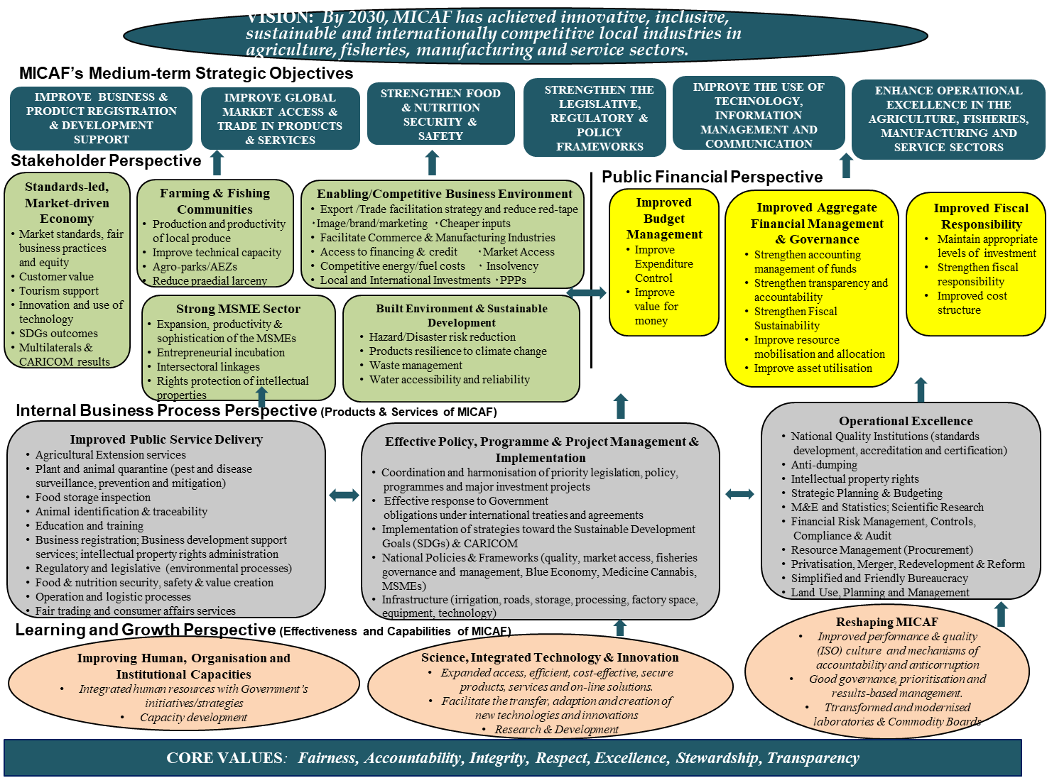
ENHANCE OPERATIONAL EXCELLENCE IN THE AGRICULTURE, FISHERIES, MANUFACTURING AND SERVICE SECTORS

6.0 PROGRAMME ACTIVITY ARCHITECTURE

[Please reproduce the Programme Activity Architecture below to demonstrate the specific alignment of the Ministry’s programmes, sub-programmes and major activities and their budgets to national outcomes and goals. The architecture should support the Government’s MTRBB. The Architecture will be vital to establishing the measurement component for each of the Ministry’s programmes, in that, key performance indicators (KPIs) should be developed to describe how improvement in performance and/or public value will be identified. The Ministry’s Programme Activity Architecture should therefore, be able to indicate, at a glance, the Ministry’s planned financial resources and supporting activities that are necessary to the implementation of the key programmes, sub-programmes and initiatives so as to achieve the desired results (outputs and outcomes) that support the respective medium-term strategic priority(ies) of the Government.]

NB. Only key programmes/initiatives of the Ministry that are supported by the budget should be included.]

PROGRAMME ACTIVITY ARCHITECTURE

National Goal
National Outcome
National Strategy
MDA Programmes & Objectives
MDA Subprogrammes
Major MDA Activities/ Initiatives
Key Performance Indicators
GOAL 3: JAMAICA’S ECONOMY IS PROSPEROUS
Outcome #8: An Enabling Business Environment Outcome #9: Strong Economic Infrastructure OutcomTechnological Enabled Society
Outcome #12: Internationally Competitive Industry Structures
8-2: Increase access to capital
8 -7: Develop the capabilities of MSMEs
12-1: Develop company sophistication and productivity
12-2: Develop economic linkages and clusters
12-3: Promote eco-efficiency and the green economy
8-3: Use trade and foreign relations to create an enabling external environment for economic growth
8-4: Strengthen investment promotion and trade facilitation

8-1: Ensure a facilitating policy, regulatory and institutional framework for business development
11-1: Integrate science and technology in all areas of development
1.0 Executive Direction & Administration
To improve access to, utilization and availability of products and services, while optimizing the use of resources.
Budget: $37.5M
2.0 Agricultural Production, Productivity & Food Security
To achieve at least 5% increase in agricultural production to meet domestic, export and manufacturing input demand by 2023
Budget: $589.5M
3.0 Industrial Development and Regulations
To improve the quality, relevance, efficiency and competitiveness of local products and services.

Budget: $685.0M
4.0 Trade Promotion and Business Development
To increase foreign and direct investment into the Jamaican economy, whilst fostering a business environment that is profitable and competitive. Budget: $258.6M
5.0 Consumer and Public Protection
To minimise the level of unfair and fraudulent business practices, while promoting public awareness, enforcing the laws, and advocating for consumers to experience a safe, fair and competitive marketplace
Budget: $28,000,000

1.1 Central Administration
1.2 Policy Planning, Research and Development
2.1 Agricultural Health & Food Safety
2.2 Fisheries Development
2.3 Agricultural Extension Services
2.4 Irrigation Services
2.5 Zoos and Gardens
3.1 Agro-Industry Development
3.2 MSME Development
3.3 Youth Agriculture and Entrepreneurship Development
3.4 Business Protection
3.5 Commodity Regulation

4.1 Trade Facilitation
4.2 Investment Promotion

5.1 Protection of Consumer Rights
5.2 Regulation of Nuclear Technologies
1.1.1 Strategic & Budget Planning & Development
1.1.2 Policy & Legislative Development Programme
1.1.2 Research and Development Programme
1.1.4 Modernisation & Transformation Programme

2.1.1 Agricultural Health & Food Safety Systems
2.1.2 Irrigation Development Programme (SPAD & EVADP Projects)
2.1.3 Competitive Products Development Programme
2.1.4 Farm Roads Rehabilitation Project
2.1.5 Fisheries Development Project
2.1.5 Agricultural Extension Programme
2.1.6 Community-based Climate Resilience Programme
2.1.7 Zoos & Gardens Maintenance

3.1.1 Agro-Parks and Agro-Economic Zone Development Programme
3.1.2 MSME & Entrepreneur Development Programme
3.1.3 Development of New Industries Programme (cannabis, castor bean & bamboo projects)
3.1.4 Promotion of traditional crops & development of non- traditional exports
3.1.5 Bodles Rehabilitation Project

4.1.1 National Trade Facilitation Programme
4.1.2 Investment Promotion Programme
4.1.3 National Quality Infrastructure Programme
4.1.4 Regulation of Trade
4.1.5 International Trade Support

5.1.1 National Consumer Policy and Implementation Plan
5.1.2 Consumer and Business Education
5.1.3 Public Education and Information Campaign
5.1.4 Complaint Investigation and Resolution
5.1.5 Consumer Protection and Advocacy
5.1.6 Market Surveillance

- % improvement in internal business processes
- Timeliness in the development, revision and implementation of policies, programmes & plans
- # of modernised and transformed divisions
- Extent to which research findings are utilised in planning and development

- % of land available and utilised for farming
- % of youths trained that remain in farming
- % reduction in import bill
- Level of self-sufficiency of selected crops
- % increase in irrigation capability

- # of new industries established
- # of agro-parks completed and operational
- % utilisation of agro-parks and economic zones
- % of MSMEs accessing financing
- % increase in export of crops (new & traditional)

- # of workshop and capability building sessions
- Level of investment
- # of BRAs integrated into the Electronic single window and trade information portal
- # and types of trade agreements with MICAF’s policy recommendations

- National Consumer Policy Action Plan
- Business Intelligence Investigations

- Timely production and/or implementation of plans, reports, policies, and projects
- Improved management of resources

- Increased diversification and marketability of agricultural outputs
- Adequate availability, access to and utilisation of food to meet demand
- Farmers trained in best practices & techniques
- New Agro-parks and Agro-Economic Zones
- Access to financing for MSMEs
- New MSMEs established
- Five new industries established

- Greater number of businesses involved in exporting of goods and services
- Local and foreign direct investment
- Trade agreements incorporating MICAF’s policy recommendation

- % reduction in customer complaints
- % increase in compliance of businesses to applicable laws and regulations
- # of education programmes & campaigns
- # of investigations conducted, and resolutions reached within 4 weeks

Key Outputs

7.0 PROGRAMME IMPLEMENTATION

[In completing this section ensure that consideration is given to the full life cycle of the respective programmes identified]

[Set out, in the following table are the programmes and sub-programmes of the Ministry. In prioritising, consideration must be given to the following conditions, as applicable:

    - relation to priority national outcomes and timelines for which these outcomes are to be achieved;

    - availability of funding;

    - satisfaction of the requirement of the Public Sector Investment Programme (PSIP); and

    - stated policies/programmes/policy initiatives.

Other key planned programmes for departments, agencies and ‘on-budget’ public bodies must be integrated into the Business Plans of their respective portfolio ministry. These planned programmes must be outlined in the ‘Portfolio Entity Medium-Term Implementation Plan’ section.]

NB. All new programmes which have gone through the Government’s prioritisation process and have been approved by Cabinet for the current year must be so indicated by the word, ‘New’.

The template is provided below, along with an example of the implementation plan for one of the Ministry’s programmes.
PROGRAMME NAME: [Insert name of programme]
PROGRAMME OBJECTIVE:  SUPPORTING GOJ POLICY PRIORITY: | Description & Context:  Programme Coordinator [if available]:
Vision 2030 National Goal: | Sector Outcome: | Budget No.:
Vision 2030 National Outcome: | Contribution to GOJ Strategic Priority:  [Provide a brief narrative on how the Ministry contributes to the realisation of the GOJ Strategic Priorities]

RESULTS MATRIX
Programme/  Sub- programme | Intended Results | Performance Indicator | Baseline | 2019/20  Projected Outturn | Estimates | Projection (Forecast) & Costs ($’000) |  |  | Functional Agency/ Dept/ Div
 |  |  |  |  | 2020/21 | 2021/22 | 2022/23 | 2023/24
[Insert Programme] |  | Outcome:
 |  | Outcome:
Staff Costs
Cash Grants
Administrative Costs
[Insert Sub-programme]  Objective:  Budget No.: |  | Outcome:
 |  | Output:
 |  | Efficiency:
 |  | Effectiveness:
[Insert Sub-programme]  Objective:  Budget No.: |  | Outcome:
 |  | Output:
 |  | Efficiency:
 |  | Effectiveness

[Continue with programmes]

PROGRAMME 2.0: INDUSTRIAL DEVELOPMENT AND REGULATION
PROGRAMME OBJECTIVE:  To improve the quality, relevance, efficiency and competitiveness of local products and services.  To improve the industrial regulatory framework and level of compliance.  SUPPORTING POLICY PRIORITY:  Strengthen MSMEs’ contribution to the Jamaican Economy | The development and sustainability of competitive and lucrative industries is an important element of the Government’s push for economic growth and job creation. Industrialization generates employment opportunities, provides educational opportunities, encourages advancement and innovation, and better utilizes resources. All of these benefits and more make industrial development extremely valuable to the Jamaican economy. However, over the last decades the manufacturing sector, which drives industrialisation, has contracted due to rapid trade liberalisation of the economy and the floating of the dollar. Intensified globalisation, which saw increased competition in export markets, cheap imports that flooded the domestic market, and the discovery of cheaper labour in other markets were external factors that contributed to the contraction of the manufacturing sector. Although faced with challenges brought about by changes in the environment in which it operates, the sector maintains its significance as one of the major engines of economic growth, job creation, and prosperity, and remains the largest contributor to GDP of all goods-producing sectors. Strategies to restore the sector back to its heyday in the 1980s are critical to achieving the country’s growth agenda targets.  The Industrial Development and Regulation Programme therefore seeks to improve and streamline business facilitation, local industry development and expansion for manufacturers, producers, service providers and MSMEs. This encompasses activities for MSME development, including business development and advisory services, entrepreneurship, finance and business environment reform, social enterprises, and youth, gender and the incapacitated in business. Through the programme, the expansion of domestic crop production will be targeted, focusing on a number of traditional products, as well as the development of orchard crops, and other fruits, along with small ruminants and castor bean, cannabis/hemp, bamboo and sea-island cotton. In tandem, linkages with other sectors and industries, as well as export with distinct markets, such as Tourism, CARICOM, Diaspora and International Markets, will be targeted.
National Goal: Jamaica’s Economy is Prosperous | Sector Outcome: Enhanced capabilities of MSMEs to establish lucrative businesses and compete in the marketplace | Budget. No.: 100/20
National Outcome 8: An Enabling Business Environment | Contribution to GOJ Strategic Priority: Inclusive Sustainable Economic Growth & Job Creation  The agriculture, fisheries, manufacturing and services sectors covers a wide portfolio that impacts numerous areas of development. The programmes under the sector enables the development of businesses, entrepreneurship, exporting of goods and services, the establishment of infrastructural development, such as economic zones and agro-parks that surge economic activities and boost foreign investment. It is therefore a major contributor to economic growth and job creation, having responsibility for over 30% of the country’s GDP.

RESULTS MATRIX
Programme/Sub programme | Intended Results | Performance Indicator | Baseline  (2018/19) | 2019/20  Projected Outturn | Estimates | Projection (Forecast) & Costs ($’000) |  |  | Functional Agency/ Dept/Div
 |  |  |  |  | 2020/21 | 2021/22 | 2022/23 | 2023/24
2.0 Industrial Development and Regulation | Increased support to the economy | Outcome: % industry contribution to GDP | 10.5 | 11.6 | 16.6  Budget: 2,500 | 21.6  Budget: 2,500 | 26.6  Budget: 3,000 | 31.6  Budget:  3,000
 | Improved country competitiveness in the global arena | Outcome: Improvement in Global Competitiveness Index Score | 65 | 74 | 70  Budget:  n/a | 66  Budget:  n/a | 62  Budget: n/a | 60  Budget:  n/a
 | Robust financial resources available for investment | Outcome:  % increase in the uptake of available funding | 1 | 2 | 3 | 3 | 2 | 1
Staff Costs | Maintenance of acceptable cost level and reduce waste | % change in staff costs | 500,000 | 500,000 | 610,000 | 650,000 | 700,000 | 720,000
Cash Grants |  | Amount ($) allocated | 15,000 | 15,000 | 15,000 | 15,000 | 15,000 | 17,000
Administrative Costs |  | % change in admin costs | 250,000 | 250,000 | 300,000 | 300,000 | 300,000 | 300,000
SUB-PROGRAMMES
2.1 MSME Development  Objective:  To increase the capacity of Jamaican MSMEs and other industry stakeholders to take advantage of transformational and development opportunities.  Budget No.: | Greater involvement of MSMEs in business, creating employment and exploiting export opportunities | Outcome:  % increase in MSMEs engaging in export opportunities | 10%  (275 MSMEs) | 10% | 10% | 10% | 13% | 15% | MSME Division, MICAF
 | More opportunities for growth of the MSME sector | Output:  # of programmes, projects, initiatives developed for MSME growth | 25 | 24 | 25 | 25 | 26 | 26
 |  | % increase in new avenues for MSMEs to access funding
 | Comprehensive Framework to guide the development of the MSME Sector | Output: Readiness of MSME Policy for approval and implementation
Efficiency:
Extent to which activities were implemented on schedule and within budget
 |  | Effectiveness Extent to which growth of the sector has been realised
2.2 Agro-Industry Development  Objective:  Budget No.: |  | Outcome:
 |  | Output:
 |  | Efficiency:
 |  | Effectiveness

8.0 MEDIUM TERM FINANCIAL RESOURCE PLAN

The financial implications of implementing the programmes, subprogrammes and activities and achieving Ministry performance targets over the period of this Business Plan are set out in the following table. It briefly outlines the estimates of expenditure for the current year and budgetary projections for the next three years, thereby facilitating a more detailed forecasting analysis for a three-year period.

Each Ministry Business Plan must include a financial summary which outlines, for the upcoming budget year and the following three financial years, the recurrent and capital costs of the policies and programmes to be implemented and which must be consistent with the expenditure ceilings contained in the Budget Call Circular.

The financial implications of planned programmes for departments, agencies and Executive Agencies, as well as ‘public bodies that are fully or partially support by the budget must be consolidated into the Business Plans of their respective portfolio Ministry. This should be demonstrated in the ‘Portfolio Agencies Medium Term Implementation Plan (Section 10).

The most current Financial Instructions issued by the Financial Secretary shall stipulate any other information relevant to the section to ensure compliance with the Financial Administration and Audit (FAA) Act.

MEDIUM-TERM FINANCIAL RESOURCE PLAN

Prog. # | Programme | Sub-Prog. # | Sub-Programme | 2018/19 | 2019/20 | 2019/20 | 2020/21 | 2021/22 | 2022/23 | 2023/24
 |  |  |  | Actual Outturn | Approved | Revised | Estimates | Forecast | Forecast | Forecast
 |  |  |  | (J$ 000) | (J$ 000) | (J$ 000) | (J$ 000) | (J$ 000) | (J$ 000) | (J$ 000)
001 | Executive Direction & Administration | 01 | Central Administration | 60 |  | 57 | 170 | 305 | 348 | 370
 |  | 02 | Policy, Planning and Development
 |  |  | Sub-Total | 60 |  | 57 | 170 | 305 | 348 | 370
002 |  | 01 |  | 20 |  | 25 | 42 | 55 | 65 | 70
 |  | 02
 |  |  |  | 20 |  | 25 | 42 | 55 | 65 | 70
 | Programme Summary |  | Total Funding | 80

9.0 HUMAN RESOURCES CAPACITY PLAN

[Set out the current staffing complement of the Ministry, as well as its portfolio Departments and Agencies, and the staffing that will be required in order to carry out the major tasks (permanent, temporary and officers on employment contract). An example is below.

In completing the HR Capacity Plan the recommended approach is that the strategic objectives of the Ministry (programme and sub-programme objectives) are considered in relation to its overall human resources capacity and needs. In doing so, reflect on any human resource issues that may have been identified in the SWOT, stakeholder analysis, and/or risk assessment activities undertaken.

HR Departments are therefore expected to have conducted gap analyses between the current and future HR needs as against the Ministry’s strategic objectives/goals and priorities in order to better provide relevant information to the development of the HR Capacity Plan below, which would present the existing and targeted or planned staffing numbers.

Note: The Ministry’s HR objectives and key initiatives that are link to the Ministry’s goals should be included in the Strategy Map and Ministry Scorecard]

9.5 | Staff Complement | Planned 2020/21 | Planned 2021/22 | Planned 2022/23 | Planned 2023/24 | Financial Implications | Source of funding
Agro-Investment Corporation | 12 | 10 | 10 | 10 | 12 | $6,500,000
Consumer Affairs Corporation | 10 | 12 | 13 | 14 | 14
Jamaica Business Development | 8 | 8 | 14 | 14 | 15
Fisheries Division | 3 | 5 | 10 |  | 10
[Continue with other Departments/ Agencies] | [Continue with related current staff complement] | [Continue with planned complement for Yr 1 | [Continue with planned complement for Yr 2 | [Continue with planned complement for Yr 3 | [Continue with planned complement for Yr 4

10.0 PORTFOLIO ENTITIES MEDIUM TERM IMPLEMENTATION PLAN

[Include in this section the required information on portfolio departments/agencies and public bodies that are fully or partially financed by the Budget (Estimates of Expenditure), as well as information on all portfolio Executive Agencies.]

The Ministry plans to implement its overall strategies to meet its performance targets for the current and projected three years through the plans/programmes/policy initiatives outlined below for the respective departments/public bodies.

[An example of a portfolio entity under the purview of the Ministry is cited below.]

10.1 RURAL AGRICULTURAL DEVELOPMENT AUTHORITY (RADA)

[Provide a brief overview of the profile of the Agency/Division/department]

The Rural Agricultural Development Authority (RADA) is a statutory body under the Ministry of Agriculture & Fisheries. RADA was established under the Rural Agricultural Development Authority Act of 1990, replacing the Land Authorities Act and began its operation on August 1, 1990. It is Jamaica's chief agricultural extension and rural development agency.

Vision
[The Vision of the departments/public body is to be developed in relation to those of the responsible Ministry.]

The Vision of RADA is to become the leader in the drive towards achieving national economic growth and stability through agricultural development.

Mission Statement
[The mission of the departments/agencies/public body is to be developed in relation to those of the responsible Ministry.]

To promote agricultural production as the main engine of growth in rural communities; provide or ensure the provision of technical, marketing, financial and infrastructure facilities and provide the social services required for the improvement of the quality of life of farm families.

Mandate
- To enhance the development of farming through an effective, efficient and sustainable Extension Service.
- To supplement information to rural development agencies, thereby assisting to advance improvements in rural infrastructure.
- To provide the supplemental social services required for the improvement of the quality of life of farm families.
- To provide technical advice to farmers of any size. To provide a reliable agricultural marketing information service.

Strategic Objectives
[This is to be derived from the mandate of the department/agency/public body]

Strategic Outcomes
- To improve the production and productivity of crops and livestock
- To encourage of new entrants to the sector with greater focus on Women and Youth
- To re-align the organization with greater focus on the technical nature of the Authority, capacity building of staff, and the development of alternative sources.

10.1.1 PROGRAMMES AND SUB-PROGRAMMES

Programme Objective: | Description & Context:  Programme Coordinator [if available]:
Supporting Ministry Programme/Sub-programme

RESULTS MATRIX
Programme/  Sub programme | Intended Results | Performance Indicator | Baseline | 2019/20  Projected Outturn | Estimates | Projection (Forecast) & Costs ($’000) |  |  | Functional Agency/ Dept/ Div
 |  |  |  |  | 2020/21 | 2021/22 | 2022/23 | 2023/24
[Insert Programme] |  | Outcome:
 |  | Outcome:
Staff Costs
Cash Grants
Administrative Costs
SUB-PROGRAMME
[Insert Sub-programme]  Objective:  Budget No.: |  | Outcome:
 |  | Output:
 |  | Efficiency
 |  | Effectiveness
[Insert Sub-programme]  Objective:  Budget No.: |  | Outcome:
 |  | Output:
 |  | Efficiency
 |  | Effectiveness

[Continue with next portfolio entity]

10.1.2 MEDIUM-TERM FINANCIAL RESOURCE PLAN
Prog. # | Programme | Sub-Prog. # | Sub-Programme | 2018/19 | 2019/20 | 2019/20 | 2020/21 | 2021/22 | 2022/23 | 2023/24
 |  |  |  | Actual Outturn | Approved | Revised | Estimates | Forecast | Forecast | Forecast
 |  |  |  | (J$ 000) | (J$ 000) | (J$ 000) | (J$ 000) | (J$ 000) | (J$ 000) | (J$ 000)
001 | Executive Direction & Administration | 01 | Central Administration | 60 |  | 57 | 170 | 305 | 348 | 370
 |  | 02 | Policy, Planning and Development
 |  |  | Sub-Total | 60 |  | 57 | 170 | 305 | 348 | 370
002 |  | 01 |  | 20 |  | 25 | 42 | 55 | 65 | 70
 |  | 02
 |  |  | Sub-Total | 20 |  | 25 | 42 | 55 | 65 | 70
 | Programme Summary |  | Total Funding | 80

10.1.3 HUMAN RESOURCES CAPACITY PLAN
Units/Divisions or Projects | Staff Complement | Planned 2020/21 | Planned 2021/22 | Planned 2022/23 | Planned  2023/24 | Financial Implication | Source of funding
[Insert name]
[Insert name]
[Insert name]
[Insert name]
[Continue with other Departments/ Agencies] | [Continue with related current staff complement] | [Continue with planned complement for Yr 1 | [Continue with planned complement for Yr 2 | [Continue with planned complement for Yr 3] | [Continue with planned complement for Yr 4]

11.0 LIST OF PUBLIC SECTOR ENTERPRISES (SELF-FINANCED)
[List only the self-financed Public Bodies for which the Ministry has portfolio responsibility, per the following format.]

Public Sector Entity | Purpose | CEO | Contact | Income (Investment income, Revenue – all cash inflows)  ($’000) |  |  |  | Expenditure ($’000) |  |  |  | Funding  (Loans & Grants) ($’000)
 |  |  |  | YR1 | YR2 | YR3 | YR4 | YR1 | YR2 | YR3 | YR4 | YR1 | YR2 | YR3 | YR4
(Name of Public Body) | (Mission) | (Name) | (Address, phone, website address and email address)
[Continue as necessary]

These programmes and sub-programmes are as they appear in the Jamaica Budget (Estimates of Expenditure).

