STRATEGIC PLAN
MINISTRY OF AGRICULTURE & FISHERIES
GOVERNMENT OF JAMAICA

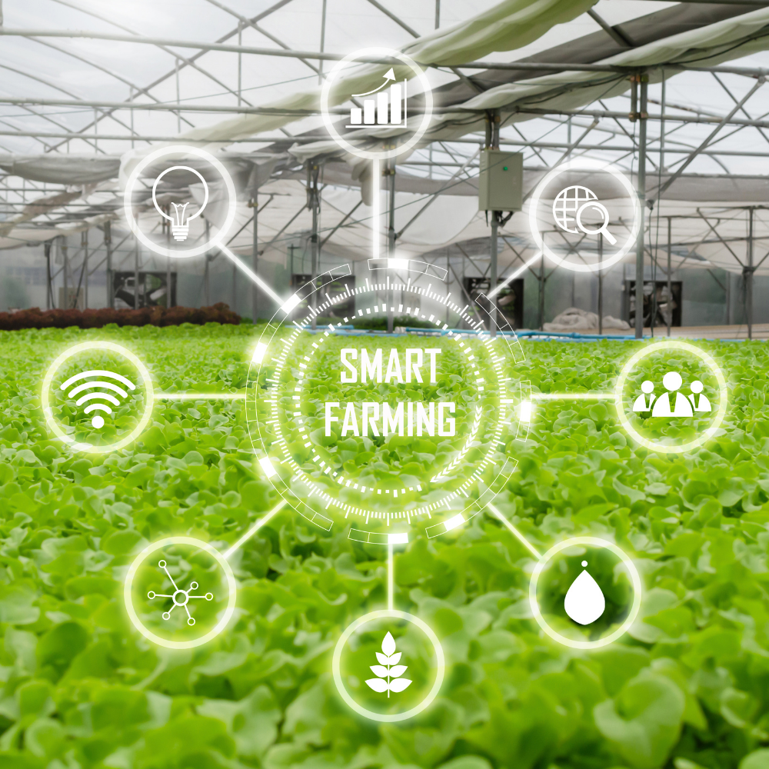
2023/2024 – 2026/2027

PREAMBLE

[This planning template serves as the required standard for preparing the Government of Jamaica’s Strategic/Corporate Plans for Ministries, in accordance with the Performance Monitoring and Evaluation System (PMES). The Template has been revised to ensure stronger alignment to the principles of results-based management and ensure conformity to the Medium-term Results-Based Budgeting (MTRBB) requirements.]

[All instructions are in italics and bracketed and should be deleted from the finalised Ministry Strategic Plan before submission. The footer on each page must either be deleted or edited to represent the Ministry. Pages, except appendices, must be numbered and reflected in the Table of Contents accordingly. The instructional sheets preceding the appendices are also to be deleted.]

[The use of pictures and/or diagrams is optional, and if used, should be done so sparingly.]

[Please note that references relating to the Ministry of Agriculture and Fisheries are used only as illustrations to help guide preparation.]

PLEASE UPDATE ALL TABLES TO REFLECT THE CURRENT AND PROJECTED FINANCIAL YEARS, AS APPLICABLE.

DOCUMENT APPROVAL AND SIGN OFF

This document has been approved as the official Strategic/Corporate Plan and Budget of the Ministry of [insert name] for the four-year period 2023/2024 – 2026/2027. The Strategic Plan and Budget of the Ministry have been prepared in consideration of the various relevant policies, legislation and other mandates for which the Ministry is responsible

Prepared by | Signature | Date
_________________________________  [Insert Name]  ________________________________  [Insert Title] | ________________ | _____________
________________________________
[Insert Department]

Approved by | Signature | Date
________________________________  [Insert Name]  Permanent Secretary | _________________ | _____________

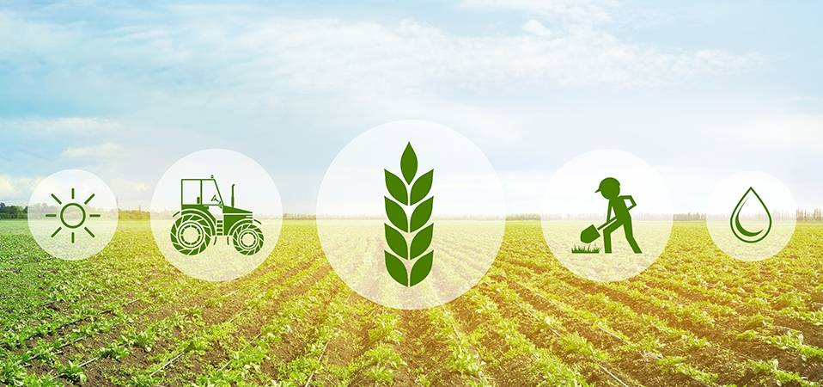

TABLE OF CONTENTS
MINISTER’S FORWARD 5
PERMANENT SECRETARY’S MESSAGE 6
ACCOUNTABILITY STATEMENT 7
SECTION ONE: INTRODUCTION AND OVERVIEW 8
SECTION TWO: STRATEGIC FRAMEWORK 11
2.0 VISION, MISSION, MANDATE & CORE VALUES 12
2.1 PRIORITIES, OUTCOMES AND STRATEGIC OBJECTIVES 13
2.2 PROGRAMMES AND SUB-PROGRAMMES 18
2.3 VISION OF SUCCESS STATEMENT 19
2.4 MINISTRY LOGIC MODEL 20
SECTION THREE: SITUATIONAL ANALYSIS 23
3.1 SUMMARY OF MINISTRY’S PERFORMANCE IN PREVIOUS MEDIUM-TERM PERIOD 24
3.2 PESTLE ANALYSIS 25
3.3 SWOT ANALYSIS 25
3.4 RISK ANALYSIS 27
3.5 STAKEHOLDER MAPPING 28
3.6 STRATEGIC ISSUES 29
3.7 STRATEGIC RESPONSE 29
SECTION FOUR: STRATEGIC ALIGNMENT 31
4.0 MINISTRY ALIGNMENT TO PROGRAMMES, PROJECTS & PRIORITY POLICIES 32
4.1 PROGRAMME ARCHITECTURE 34
SECTION FIVE: STRATEGY IMPLEMENTATION 36
SECTION SIX: MEDIUM TERM RESOURCE PLAN 48
6.0 MEDIUM TERM FINANCIAL RESOURCE PLAN 49
6.1 HUMAN RESOURCES CAPACITY PLAN 51
SECTION SEVEN: MONITORING & EVALUATION 52

MINISTER’S FORWARD
[Message should include the reaffirmation of national strategies and direction of the Ministry, and commitment statement to the strategic planning process. The message must be signed by the Honourable Minister.]

PERMANENT SECRETARY’S MESSAGE
[Message should include the Ministry’s key initiatives that are being implemented; and their alignment to national goals and outcomes, and the GOJ strategic priorities. Reference should also be made, where necessary, to the global/ international context in which the Ministry operates.]
[Message must be signed by the Permanent Secretary.]

ACCOUNTABILITY STATEMENT
[See example of an Accountability Statement below. The Accountability Statement developed by each Ministry must be signed by the Permanent Secretary. However, in the case of the Ministry of Finance, the Statement must be signed by both the Honourable Minister and the Financial Secretary].

This Strategic Plan for the next four years, commencing April 1, 2023, was prepared under my direction in accordance with the policy directives outlined by the Government of Jamaica, and the authority delegated to me under Section 16 of the Financial Administration and Audit (FAA) Act. The Plan outlines the Ministry’s strategies that contribute to the achievement of the Government’s agenda, and specifically, the programmes for which appropriate monitoring and evaluation mechanisms are being deployed to ensure their timely and cost-effective implementation.

The Ministry’s priorities outlined in this Strategic Plan were identified in context of the Government’s medium-term priorities and fiscal targets. I am, therefore, committed to achieving the planned results laid out in this Business Plan.

[Signature]
Permanent Secretary
[Ministry of Agriculture and Fisheries]

SECTION ONE

Introduction and Overview
1.0 INTRODUCTION & OVERVIEW
[Provide an overview of the profile and purpose of the Ministry, its areas of responsibilities, and the context in which the plan is being developed. The introduction and overview should also outline, but is not limited to, the Ministry’s contribution to the GOJ Medium-Term Strategic Priorities, as well as the linkage to Vision 2030 National Goals and Outcomes, and the Sustainable Development Goals].

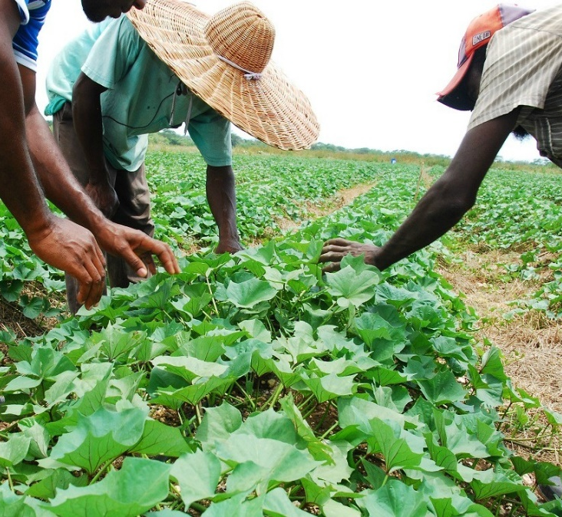

SECTION Two

Strategic Framework

2.0 VISION, MISSION, MANDATE & CORE VALUES
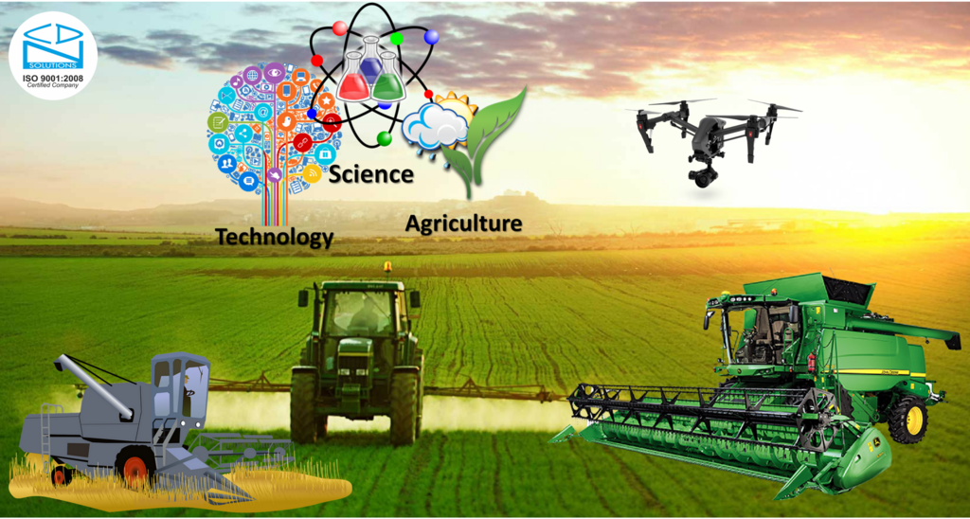
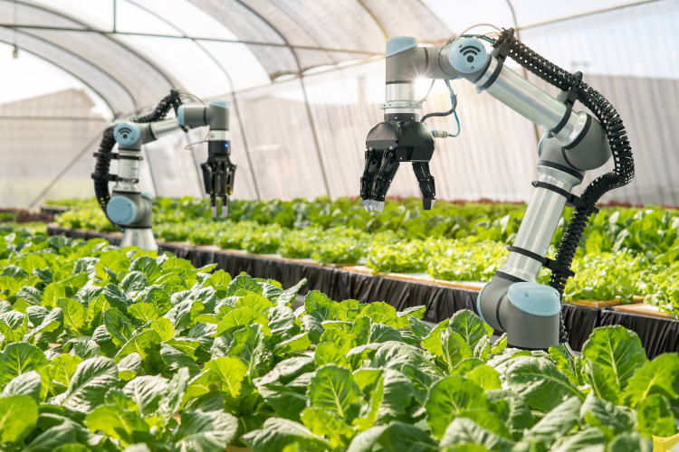
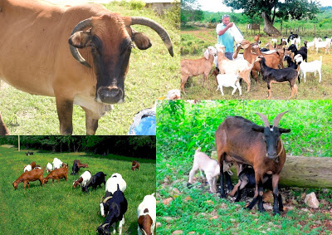
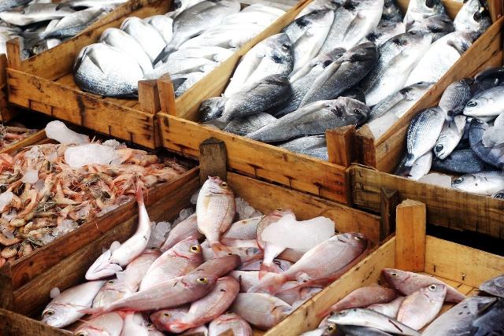
Core Values
[Indicate the core principles that are important to the Ministry and which will govern its conduct and guide its actions]

Fairness: We aspire to provide access to opportunities to everyone regardless of sex, age, socio-economic status, creed and ability.

Accountability: We commit to being answerable to the relevant authorities.

Integrity: We will adhere to conducting transactions with transparency, high moral standards and professionalism.

Respect: We acknowledge our differences and will provide a safe supportive environment in which all staff are valued and engaged in interactive communication.

Excellence: We commit to a high standard of service delivery to clients and co-workers through accurate, accessible and up-to-date data, innovation and continuous improvement.

Stewardship: We interact and collaborate with all stakeholders with understanding of our integral role to ensure the sustainable development in the agriculture, fisheries, manufacturing and service sector.

Transparency: We standardise operating procedures that are accessible and understandable to all.

Mission
[The Mission must indicate the overall purpose for which the Ministry currently exists, whilst capturing the core business of the Ministry]

For example::
“To create an enabling environment which grows and sustains industries in agriculture and fisheries, while fostering gender equality and social inclusion in all our policies, programmes and projects.”

Vision
[The Vision must indicate the long-term desired change to the state of the Ministry, as a result of its programmes.]

For example:
“The leading government Ministry that drives economic development through agriculture and fisheries”

Mandate
[The mandate describes what the organisation has to do based on the programmess and services it is formally contracted to offer. It constitutes the foundation of what an organization must accomplish as a means to remain connected with the fulfilment of the vision and mission statements.]
- To develop sustainable food systems by driving local production of primary agricultural produce, livestock and fisheries and integrate production up the value chain.
- To promote a lucrative agribusiness sector that drives productivity and boost job creation.
- To increase the application of technology, innovation, R&D to agricultural production, MSMEs and fisheries.

2.1 PRIORITIES, OUTCOMES AND STRATEGIC OBJECTIVES

[Outline the priority areas that the Ministry will focus on, and the supporting short to medium-term outcomes and strategic objectives].

[Priorities are the specific areas that an organisation has chosen to focus on during the planning period. They represent the things that are most important or what must be done first to support the achievement of the desired strategic outcome(s). Prioritization is an important aspect of strategic planning. It helps the implementation team to achieve the most important parts of the strategic plan. Taking into account the mission and vision of the Ministry, the strategic issues identified from the situational analysis, and the strategic position the Ministry seeks to achieve in the medium term, the Ministry should define the priorities that will be pursued over the medium term.]

[Outcomes are the desired results that an organisation aims to achieve under each priority. They represent the end results of a plan of action implemented to achieve the long term effect of an intended project, programme or policy. They express the changes or benefits that will be achieved if the initiatives and approaches are implemented successfully. These changes can be short-term (usually changes in knowledge, skills, processes, capacity, access), intermediate (changes in practices, behaviour and performance) or long-term (changes in condition and status).

[Strategic Objectives are purpose statements that help create an overall vision and set goals and measurable steps for an organization to achieve the desired outcomes. They set the major benchmarks for success and are designed to be measurable, specific and realistic translations of the mission statement and outcomes that can be used by management to guide decision-making. In crafting the strategic objectives, consideration should be given to the functional areas of the organisation. The Ministry’s strategic objectives should therefore be balanced across the four perspectives of the balanced scorecard, namely i) Learning and Growth/Capacities & Capabilities, ii) Internal Business Processes, iii) Customer/Stakeholder, and iv) Financial. Ideally, if subscribed to this approach, the organization should have between 10 to 20 strategic objectives to support the outcomes being pursued.]

[Each strategic objective should be supported by an implementation strategy, which is a plan of action to achieve an objective or outcome. This strategy describes how the strategic objective will be achieved by outlining the approach to implementation. Strategies are about making decisions and deciding which initiatives (projects, policies, programmes) will move the Ministry towards its vision, while keeping a close watch on what could slow down implementation and derail the successful achievement of the objectives.]

[NOTE: As a best practice, the organisation should strive for 3 to 5 priorities. Each programme should be supported by at least one priority at the impact level (long-term) of the logic model. Each sub-programme should have at least one outcome, which should thereafter be supported by at least one strategic objective.]

PRIORITY 1.0 OPTIMISATION OF AGRICULTURAL & AGRIBUSINESS PRODUCTION AND PRODUCTIVITY

Description/Rationale: [Briefly state why this is considered a priority]

The ability to consistently achieve high and sustainable levels of agricultural production and productivity is critical to meet the agricultural needs of the populace and to ensure food security. Over the years, productivity has been adversely impacted by several factors, such as low investment in agriculture, challenges with meeting the production level targeted due to adverse weather conditions, poor farming practices, lack of adequate technological solutions, and lack of adequate irrigation services. To this end, agricultural production and productivity must be optimized if gains are to be made in having agriculture truly be a primary driver of economic growth.

OUTCOME #1 | Competitive Agribusiness & Agriculture Industry Structures
STRATEGIC OBJECTIVE 1.0:  STRATEGIES | To increase, by at least 15%, the output of the agricultural sector by 2026.  The Ministry will achieve this objective through the following implementation strategy(ies):  - Develop and implement action plans for four (4) new emerging produce/ livestock/ fisheries in the agriculture and agribusiness sectors and continue to build out agro-parks and agro-economic zones at strategic locations across the island.
[Continue with strategic objectives, as deemed necessary]
STRATEGIC OBJECTIVE 2.0:  STRATEGIES | To increase the value-added production of five (5) select crops by 15% by March 2026.  The Ministry will achieve this objective through the following implementation strategy(ies):  - Analyse and develop value chain solutions for select agricultural crops that improve traceability, biosecurity and food security through digital transformation, and  - Develop innovative systems and approaches to attract investment to support value chains and drive job creation.

OUTCOME #2 | Healthier and sustainable level of disease-free output from the agricultural sector
STRATEGIC OBJECTIVE 3.0:  STRATEGIES | To reduce to 1.0%, the incidence of select pests, diseases and food borne pathogens for ten (10) priority crops and livestock by 2026.  The Ministry will achieve this objective through the following implementation strategy(ies):  - Boost investment in pest control and management by procuring adequate materials and resources that have been proven to address crop production deficiencies. The strategy will also involve equipping farmers with the requisite skills, techniques and technological innovation, commensurate with international best practice in farming, to adequately treat with, and substantially eliminate, the presence of pests and diseases.

OUTCOME #3 | High proportion of youth, women and persons with disability, or any vulnerable group represented in farming, and sustaining themselves from agricultural activities.
STRATEGIC OBJECTIVE 4.0:  STRATEGIES | To have at least 20% of beneficiaries of the Ministry’s programmes be youth, women and persons with disability, or any vulnerable group from the agricultural sector by 2025.  The Ministry will achieve this objective through the following implementation strategy(ies):  [Insert the strategies that will be pursued to achieve the strategic objectives (that is, briefly explain how the objectives will be realised). These strategies should be aligned to, and guide, the development of the initiatives (projects, programmes and policies) that will be developed and executed during the planning period.]

OUTCOME #4 | Greater use and application of research, technological solutions and innovation to boost agricultural production and productivity
STRATEGIC OBJECTIVE 5.0:  STRATEGIES | [Insert the strategic objective(s) to support this outcome.]  The Ministry will achieve this objective through the following implementation strategy(ies):  [Insert the strategies that will be pursued to achieve the strategic objectives (that is, briefly explain how the objectives will be realised). These strategies should be aligned to, and guide, the development of the initiatives (projects, programmes and policies) that will be developed and executed during the planning period.]

OUTCOME #5 | Increased access and availability of irrigation services in agriculture
STRATEGIC OBJECTIVE 6.0:  STRATEGIES | [Insert the strategic objective(s) to support this outcome.]  The Ministry will achieve this objective through the following implementation strategy(ies):  [Insert the strategies that will be pursued to achieve the strategic objectives (that is, briefly explain how the objectives will be realised). These strategies should be aligned to, and guide, the development of the initiatives (projects, programmes and policies) that will be developed and executed during the planning period.]
PRIORITY 2.0: INVESTMENT IN THE BLUE ECONOMY AND AQUACULTURE GROWTH

Description/Rationale: [Briefly state why this is considered a priority]

OUTCOME #6 | Enhanced resilience, lucrativeness and sustainability of the fisheries sub-sector
STRATEGIC OBJECTIVE 7.0:  STRATEGIES | To increase the output from the fisheries sector by 10% by 2026  The Ministry will achieve this objective through the following implementation strategy(ies):  [Insert the strategies that will be pursued to achieve the strategic objectives (that is, briefly explain how the objectives will be realised). These strategies should be aligned to, and guide, the development of the initiatives (projects, programmes and policies) that will be developed and executed during the planning period.]

OUTCOME #7 | Increased economic and ecological value from fisheries production and aquaculture activities
STRATEGIC OBJECTIVE 8.0:  STRATEGIES | [Insert the strategic objective(s) to support this outcome.]  The Ministry will achieve this objective through the following implementation strategy(ies):  [Insert the strategies that will be pursued to achieve the strategic objectives (that is, briefly explain how the objectives will be realised). These strategies should be aligned to, and guide, the development of the initiatives (projects, programmes and policies) that will be developed and executed during the planning period.]

PRIORITY 3.0: STRENGTHENED ORGANISATIONAL CAPACITY & EFFICIENCY TO DELIVER RESULTS

Description/Rationale: [Briefly state why this is considered a priority]

OUTCOME #8 | High performing results-oriented organisation that consistently delivers results in line with service delivery standards
STRATEGIC OBJECTIVE 9.0:  STRATEGIES | To allocate and optimally use human and financial resources based on agreed national and Ministry priority policies.  The Ministry will achieve this objective through the following implementation strategies:  [Insert the strategies that will be pursued to achieve the strategic objectives (that is, briefly explain how the objectives will be realised). These strategies should be aligned to, and guide, the development of the initiatives (projects, programmes and policies) that will be developed and executed during the planning period.]

OUTCOME #9 | Improved delivery of, and satisfaction with, the Ministry’s and its portfolio entities’ products and services
STRATEGIC OBJECTIVE 10.0:  STRATEGIES | To improve the level of efficiency with which the Ministry’s policies, projects and programmes bring about the desired changes articulated through outcomes and objectives.  The Ministry will achieve this objective through the following implementation strategies:  [Insert the strategies that will be pursued to achieve the strategic objectives (that is, briefly explain how the objectives will be realised). These strategies should be aligned to, and guide, the development of the initiatives (projects, programmes and policies) that will be developed and executed during the planning period.]

PRIORITY 4.0: AGRICULTURAL HEALTH & FOOD SAFETY

Description/Rationale: [Briefly state why this is considered a priority]

OUTCOME #10 | [Insert the Outcome]
STRATEGIC OBJECTIVE 11.0:  STRATEGIES | [Insert the strategic objective(s) to support this outcome.]  The Ministry will achieve this objective through the following implementation strategies:  [Insert the strategies that will be pursued to achieve the strategic objectives (that is, briefly explain how the objectives will be realised). These strategies should be aligned to, and guide, the development of the initiatives (projects, activities, programs and policies) that will be developed and executed during the planning period.]

2.2 PROGRAMMES AND SUB-PROGRAMMES
[The Ministry’s programmes are being planned and developed with great consideration of the National Development Plan - Vision 2030, Jamaica; Medium Term Economic Programme (MTEP); Medium Term Socio-Economic Policy Framework and the Medium-term Results Based Budgeting for Jamaica. With this in mind, the Ministry’s programmes and sub-programmes for the medium term are as indicated below.

List the programmes and sub-programmes of the Ministry, as identified in the Ministry’s Rationalized Programme Budget Structure that were developed during the MTRBB consultation process]

PROGRAMME #1: | EXECUTIVE DIRECTION AND ADMINISTRATION
Sub-programme 1.1  Outcome(s): | Central Administration  High-performing results-oriented organisation that consistently delivers results in line with service delivery standards
Sub-programme 1.2  Outcome(s): | Policy, Planning and Evaluation  Improved delivery of, and satisfaction with, products and services
PROGRAMME #2: | AGRICULTURAL PRODUCTION, PRODUCTIVITY & FOOD SECURITY
Sub-programme 2.1  Outcome(s) | Agricultural Health & Food Safety  Healthier and sustainable level of output from the agricultural sector
Sub-programme 2.2  Outcome(s) | Agro-industry Development  Competitive Agribusiness & Agriculture Industry Structures
Sub-programme 2.3  Outcome(s) | Agricultural Research and Development  Greater use and application of research, technological solutions and innovation to boost agricultural production and productivity
Sub-programme 2.4  Outcome(s) | Irrigation Services  Increased access and availability of irrigation services in agriculture
Sub-programme 2.5  Outcome(s) | Fisheries Development  Increased economic and ecological value from fisheries production and aquaculture activities  Enhanced resilience, lucrativeness and sustainability of the fisheries sub-sector
Sub-programme 2.6  Outcome(s) | Agricultural Extension Services  Utilisation of new and emerging technologies, best practices and innovative solutions for enhance the production of select crops
Sub-programme 2.7  Outcome(s) | Youth Agriculture and Entrepreneur Development  High proportion of youth, women and persons with disability, or the vulnerable represented in farming, and sustaining themselves, from agricultural activities.
Sub-programme 2.8  Outcome(s) | Management of Zoos and Public Gardens  Sustainable maintenance and upkeep of the gardens and plant species to ensure preservation of biodiversity.

2.3 VISION OF SUCCESS STATEMENT
[In this section the Ministry is to describe its overall (or grand) strategy in the form of a narrative. This narrative should ideally be no more than one page in length. This vision of success statement, sometimes also referred to as a statement of purpose, is a clear and succinct guide to the implementation of the plan, and the creation of significant and lasting public value. The statement is meant to provide a future-orientated theory of what an organization should do and how they should do it to achieve success and help organizational members and key stakeholders understand the core requirements for success. It is typically written after acceptance of the overall strategy and the review and adoption of the plan by key stakeholders. The statement is an integral component of an organization’s overall strategic plan.

The statement should integrate the Ministry’s mandate, vision, mission, outcomes and objectives into a coherent framework that stakeholders can use to inform major and minor organizational decisions and actions that are needed to implement the plan and deliver public value. The statement will guide the Ministry and its departments, agencies and public bodies in formulating its business practices and procedures, without spelling out what those methods will look like when the business opens its doors. This means that while the guidance offered should be specific and reasonable, but it is also pitched at a high conceptual level. The statement is therefore descriptive rather than prescriptive to allow for flexibility and adaptability of the plan where this becomes necessary.]

Sample Vision of Success Statement

Agriculture remains at the very heart of Jamaica’s developmental agenda where people, the environment, and the economy must be managed in a sustainable manner. The Ministry of Agriculture and Fisheries will provide a strategic framework to ensure that the country achieves food and nutrition security by 2030 and will do so by promoting an agricultural sector that is knowledge-based, innovative, entrepreneurial, environmentally sustainable, resilient to weather and climate change, competitive, and profitable for those who work the land. Agriculture must be positioned as an equitable wealth generator producing food and related commodities to meet local and export demands while providing meaningful employment to a significant portion of the rural population.

The creation of a modern, resilient, sustainable, and competitive agricultural sector will require investments in a better trained and technologically savvy workforce, expanded and upgraded extension services, more extensive and climate resilient irrigation systems, improved rural roads, effective systems for pest surveillance and control, and more effective and efficient marketing and distribution channels. This upgraded agricultural sector will include both terrestrial and aquatic areas as a balanced and robust food sector needs to incorporate both the green and blue economies. This upgraded agricultural sector will also be integrated into other sectors of the economy such as tourism, renewable energy, biotechnology, pharmaceuticals, cosmeceuticals, and materials science to create linkages and deepen local value chains to increase local production. These improved outcomes will require new policies and regulations to provide incentives and guidance, and strong partnerships with education, research and the private sectors to attract investments, produce skilled farmers, and provide the latest scientific and management knowledge to upgrade the sector.

2.4 MINISTRY LOGIC MODEL

[Develop a logic model/results chain for the Ministry. A logic model is a visual representation of the organisation’s planned programming. It is a road map of how the organisation intends to achieve desired outcomes using defined resources and strategies. It is typically a one-page visualization that briefly describes the organisation’s challenges, inputs, activities, outputs, and outcomes, and outlines the pathway to success. The logic model allows for the communication of performance measurements specifically and clearly.]

[The Logic Model is developed per guidance below:

- Identify the organisation’s priorities: Start by defining your organization’s mission, vision, values, and needs assessment. Think about the current challenges and note the overall impact the organisation intends to have over a given period.

- Identify the Strategic Objective – Develop a brief and broad goal of the Ministry that serves to address a problem specific to the Ministry’s mandate. These objectives have medium to long term applications.

- Assess your current inputs: The organisation’s inputs are the resources that are put into a program, campaign, or intervention. These resources can be financial, grants, personnel, office materials, etc. Think about the investments needed to make to achieve success over a defined period.

- Define your outputs: Outputs are also known as activities and participation. These are the events that need to happen or the tasks that need to be performed by the organisation to produce the desired outcomes (e.g. conducting workshops, delivering services, developing products). Also of important is the required level of participation and contributions of donors, volunteers, board members, partners, and external agencies.

- Determine outcomes: Outcomes are the organisation’s desired results over a period or at the end of a program or campaign. There are three types of outcomes:
  - Immediate/Short-term Outcomes: These are the immediate effects of the program, campaign, or activities. They often depend on the knowledge and attitudes of the intended audience, i.e., donors and supporters. This can include increased brand awareness or changes in attitudes and behaviours towards the organization.
  - Intermediate/Mid-term Outcomes: These outcomes are the bridge between the short-term and long-term outcomes. They determine the changes expected in the medium to long term, which will ensure the programme objectives are achieved. For example, they can include the actions that donors and supporters take after gaining more knowledge and awareness about the organizations or programs.
  - Long-term Outcomes: These outcomes refer to the long-lasting changes or impacts of activities. They are directly connected to the short-term and mid-term outcomes and usually occur in the aftermath of both. Typically, they include social, economic, civic, or environmental changes that affect the organisation’s beneficiaries.

- Identify critical assumptions – Determine assumptions at each level starting from activities]

MINISTRY LOGIC MODEL
IMPACT  [LONG-TERM] | Long-term intended effects/changes. Example: Changes in status or life conditions (social, economic, civic or environmental)
PRIORITIES
INTERMEDIATE OUTCOMES | Intended effects that occur over the mid-term (months-years). Example: Changes in behaviour; performance; practice; policies; supply & demand; relevance, effectiveness and efficiency of products and services; and decision-making
IMMEDIATE OUTCOMES | The immediate changes expected to be seen on completion of the programme. Example: Changes in skills, capacity, attitudes, knowledge, systems, strategies, processes and procedures.
OUTPUTS | The products or services produced from the activities of the programme
ACTIVITIES | The primary, intentional mechanisms by which program outcomes are achieved
INPUTS | Resources needed to operate programmes

ASSUMPTIONS | EXTERNAL FACTORS
The beliefs about the programmes, the people involved, and how it will work | The environment in which the programme is being delivered (economic, political, cultural, historical, and social contexts etc.)
MINISTRY RESULTS CHAIN [EXAMPLE]
IMPACT  [LONG-TERM] | Internationally Competitive and Resilient Agriculture & Fisheries Sector Increased Contribution of the Sector to Jamaica’s Economy |  |  | Improved Service Delivery and Organizational Efficiency
PRIORITIES | AGRIBUSINESS & AGRICULTURAL OPTIMISATION | INVESTMENT IN THE BLUE ECONOMY & AQUACULTURE GROWTH | AGRICULTURAL HEALTH & FOOD SAFETY | STRENGTHEN ORGANISATIONAL CAPACITY & EFFICIENCY
INTERMEDIATE OUTCOMES | - Increased production & value-added export of select crops  - Reduction in select products on the food import bill  - Increased production along targeted value chains | - Increased consumption of local aquaculture products and offshore pelagic  - Increased production of more variety of fisheries products  - Greater access to export markets for products | - Increased application of R&D, technology and environmental best practices in project designs  - Increased fresh food and livestock exports  - Zero/minimal biological risks  - Enhanced farming practices and crop yield | - High-performing results-oriented organisation that applies and adopts new learning, skills systems and processes to deliver results in line with service delivery standards
IMMEDIATE OUTCOMES | - Increased application of skills, techniques and environmental best practices in the sector  - Increased capacity to harvest crops in line with production levels  - Improved crop yield | - Improved skills and capability in select fisheries production & productivity  - Increased awareness of income-generating opportunities in the Blue Economy  - Greater awareness of local aquaculture products | - Better designed or renovated farming facilities  - Improved skills and capacity of farmers to produce better quality and more output  - Greater use of best-fit technology in farming | - Increased knowledge & capability of the Ministry to deliver results in line with expectations of the corporate/operational plan  - Strengthened operational processes, systems & procedures across the organisation
OUTPUTS | - Agro-Parks & Agriculture Economic Zones  - Irrigation facilities (Essex Valley, South Plains)  - Harvested crops and animal products  - Arable lands in production  - Exportation of crops  - Updated National Irrigation Development Plan  - Irrigated farmlands  - Value Chains for select crops | - Registered & licensed fishers and vessels  - Capacity Building Sessions & trained fishers  - New or revised fisheries-related policies & legislation  - Select Fisheries Management Plans  - Fisheries facilities (ponds, nurseries etc.)  - Fish products produced | - Rehabilitated research centre [Bodles]  - Global GAP Certified farmers & farming facilities  - New and/or improved technologies, methods and/or documented best practices  - Findings from Research and Studies  - Inspection & Surveillance Reports | - Training Sessions/Workshops, Trained staff  - Reports – Audits, Projects, Financial, Performance, Procurement  - Plans -Corporate & Operational, Projects  - Relevant Policies, Strategy Document, ISO Certification Update, Legislation, SOPs
ACTIVITIES | - Development/Operationalization of Agro-Parks & AEZs  - Establish value chains for select products  - Revision of the National Irrigation Development Plan  - Irrigation of farmlands | - Registration & licensing of fisherfolks & vessels  - Train fishers in port-harvest & other techniques  - Development of fisheries policies & legislation  - Development of new & underutilized fisheries  - Construction of nurseries, ponds & sanctuaries | - Rehabilitate research centres and farm roads  - Training and certification of farmers & farms  - Conduct surveillance for pests & diseases  - Undertake research on key issues and new technology & practices in the sector | - Capacity building & Staff development, R&D  - Auditing, budgeting, project management  - Preparation of corporate plans, Strategy Documents, policies, legislation, SOPs
INPUTS | Human Resources (staff, consultants, farmers etc.) Financial Resources (Budget, Project financing, Grants etc) Partnerships Infrastructure, Equipment, Facilities

ASSUMPTIONS | EXTERNAL FACTORS
- Resources and capacity will be available for programme delivery  - Availability of labour and technical capacity  - Buy-in and support from all Divisions, Departments and Agencies | - Inflation Low levels of investment Heavy Rainfall/ Drought Shocks/ Inefficiencies  - Loss of Skilled Workers Shrinking Talent Pool Natural Disasters Prevalence of Pests & Diseases  - Ongoing disruption caused by the COVID-19 pandemic

SECTION Three

Situational Analysis

3.0 SITUATIONAL ANALYSIS
[The situational analysis provides the context and knowledge for planning. A situational analysis describes an organization’s competitive position, operating and financial condition and general state of internal and external affairs. It is useful when defining the organisation’s capability, competitor, and the customer to determine the crucial steps that the business needs to take within the marketplace.
A combination of tools can be used to conduct the situational analysis. Some of the most widely used tools are the SWOT Analysis, Stakeholder Analysis, PESTLE Analysis and 5C’s [company, competitors, customers, collaborators and climate] Analysis. The tools below (and from the Annex to the Plan) should be used to summarise the situational analysis.]
[Factors to consider when doing a situational analysis

- Product Situation - Determine your current product. You may want to view this definition in parts such as the core product and any secondary or supporting services or products that you sell. Viewing your products and services separately helps determine how each relates to your core clients' needs.

- Competitive Situation - Analyse your main competitors and determine how they compare to your business such as competitive advantages, as applicable.

- Distribution Situation - Review your distribution situation in terms of how you get your products to market, such as through distributors or other intermediaries.

- Environmental Factors - Determine the external and internal environmental factors, which can include economic or sociological factors that impact your business's performance.

- Opportunity and Issue Analysis - Conduct a SWOT analysis to determine any strengths, weaknesses, opportunities, and threats that may affect your organisation and its performance.]

[Insert a narrative that summarises the situational analysis undertaken by the Ministry. This section should take into account the findings and insights gained from conducting the environmental assessment using the analytical tools below as well as the assessments of past performance and from monitoring and evaluation activities.]

3.1 SUMMARY OF THE MINISTRY’S PERFORMANCE IN THE PREVIOUS MEDIUM-TERM PERIOD
[It is important to provide a summary of performance during the preceding medium-term period as part of accountability and transparency relating to previous planning efforts, and to provide information to support learning to help guide the current planning cycle. Performance reports provide useful insights for management that can be used to help develop forecasts, prepare communication plans, guide budget planning, and improve strategic decision-making. Tracking and analysing past performance help to determine success, identify performance gaps, and identify areas for improvement and opportunities to justify scaling up successful programmes and projects or terminating unsuccessful programmes and projects. Information on past performance will make the details of current strategic framework more coherent and understandable. Ministries can summarize past performance in a brief narrative but can support this narrative with graphs, charts, tables, and photographs, if these are available.]

3.2 PESTLE ANALYSIS
[The PESTLE analysis is regarded as a complementary tool to a SWOT Analysis in that it expands on the analysis of the external environment by looking in detail at specific types of issues that frequently have an impact on implementation of projects/initiatives. The PESTLE Analysis is a tool that identifies and analyses the key drivers of change in a strategic or business environment. The abbreviation stands for political, economic, socio-cultural, technological, legal, and environmental factors.]
POLITICAL
ECONOMICAL

SOCIO-CULTURAL
TECHNOLOGICAL

LEGAL

ENVIRONMENTAL

3.3 SWOT ANALYSIS
[Undertake a SWOT analysis of the environment in which the Ministry operates. A SWOT analysis is a technique used to identify strengths, weaknesses, opportunities, and threats in order to develop a strategic plan or roadmap for the organisation.]

STRENGTHS | WEAKNESSES
INTERNAL  “What do we do well?” | INTERNAL  “What can be improved?”

OPPORTUNITIES | THREATS
EXTERNAL  “What changes are taking place  in the environment which might  allow us to better achieve our mission?” | EXTERNAL  “What changes in the environment  do we need to guard against  in doing our work?”

3.4 RISK ANALYSIS
[Using the risk matrix below, outline the key risks facing the organisation, ranking them according to their likelihood to occur and impact on the realisation of the Ministry’s outcomes and objectives.]

Note: This risk matrix complements the Risk Register in the Annex to the Strategic Plan. The risks identified in the heat map below should also be translated to the risk register in the annex.

RISK CATEGORY/RATING  (WITH RISK SCORE) | LOW RISK | MEDIUM RISK | HIGH | VERY HIGH
 | 0 - 4 | 5 - 8 | 9 -15 | ≥ 16

LIKELIHHOD
5  VERY HIGH |  | 10 |  | 5
4  HIGH  [POSSIBLE] | 2 |  | 3
3  MEDIUM  [LIKELY] |  | 9 | 8 | 4
2  LOW | 7 |  | 6 | 1
1
VERY LOW

 | 1  INSIGNIFICANT/ VERY LOW | 2  LOW | 3  MEDIUM | ≥4  HIGH -  VERY HIGH

IMPACT

[LIST THE TOP RISKS AND PLACE THEM (BY NUMBER) IN THE MATRIX ABOVE]
RISKS:
1. Earthquake/Tsunami 2. Increased input costs 3. Praedial Larceny 4. Pest & Diseases 5. Long periods of rainfall/ droughts 6. Limited access to funding 7. Loss of skilled workers/Lack of adequately trained and certified experts 8. Limited market access 9. Few women in farming 10. Inadequate irrigation services

Refer to Annex A for a more detailed assessment of the risks highlighted below and the strategies to be employed should these risks materialise.

3.5 STAKEHOLDER MAPPING
[Provide a mapping of the Ministry’s key stakeholders, ranking them according to their power/influence and interest in respect of the successful implementation of the Ministry’s programmes, policies and projects and the achievement of the objectives. This analysis allows for an identification of who the organization’s internal and external stakeholders are, how they evaluate and influence the organization, its policies, programmes, and projects, what the organization needs from them, and how important they are.]

The dynamism of the agriculture and fisheries sector results in a wide range of stakeholders, some with the power and influence to impact the activities and pursuits of the sector as it seeks to further grow Jamaica’s competitiveness in the global industry. Against this background, a stakeholder mapping was conducted for the sector, to identify the key players and the relationships for the purpose of determining measures, metrics and benchmarks for managing operations, strategic alliances and growth. The result of the stakeholder mapping is shown below, and is supported by a Stakeholder Register at Annex B.
POWER/ INFLUENCE
KEEP SATISFIED | - International Development Partners | MANAGE CLOSELY | - HM, Agriculture & Fisheries
 | - Financial Sector- Capital Markets & Lending Institutions |  | - Ministry of Finance & the Public Service
 | - Large Food Supply & Distribution Conglomerates |  | - Ministry of Health & Wellness
 | - Large Farmers |  | - Small Farmers
 | - National Environmental & Planning Agency
MONITOR | - Micro, Small &Medium Sized Enterprises | KEEP INFORMED | - Ministry of Foreign Affairs & Foreign Trade
 | - Scientific Research Council |  | - Ministry of Tourism
 | - Planning Institute of Jamaica |  | - Ministry of Industry, Investment & Commerce
 | - Civil Society |  | - Imports of inputs for production
 |  |  | - Importers/Exporters of produce, livestock and value-added products

Low High
INTEREST

3.6 STRATEGIC ISSUES
[Using the analyses conducted by the organisation, including the review of prior years’ performance and the environmental assessment, outline the key strategic issues that have emerged from the analysis. Strategic Issues are the key areas of concern that are driving the development and implementation of the plan. These issues can be problems, opportunities, market shifts or anything else that requires a solution or decision in order to improve the state of being of the organisation].

Several strategic issues were revealed from undertaking the performance review and situational analysis. These issues are key areas around which decision making will take place in order to address areas that are necessary to successfully advance the Ministry’s agenda for the medium term through targeted interventions and strategies that will ensure the realisation of the outcomes and strategic objectives being pursued. The key issues facing the sector are as outlined below:

- Lack of adequate capacity and capability in project management, research and development, and procurement, among others.
- Inadequate support to farmers and fishers.
- Lack of adequate diversification and market segmentation of agricultural products.
- Inability to consistently meet rising demand for more food of higher quality.
- Lack of adequate investment in farm productivity.
- Opportunities in new and emerging industries, such as bamboo, castor bean oil, and sea cucumber, remain untapped.
- Poor rate of adaptation to learning and implementation of new technologies and best practices.
- Lack of available arable lands for farming.

3.7 STRATEGIC RESPONSE
[Outline the strategic response to the key strategic issues facing the organisation. This provides the conclusion to the situational analysis. This section should lead the reader to identify specific strategies that will be communicated through the programmes of the Ministry].

The Commission’s key stakeholders include the following

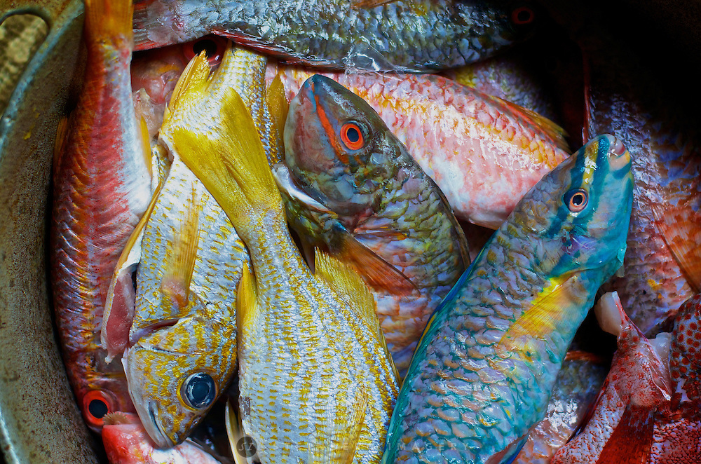

SECTION Four

Strategic Alignment

4.0 MINISTRY ALIGNMENT TO PRIORITY PROGRAMMES, PROJECTS & POLICIES

[The Ministry’s priority programmes and key related actions must be aligned to the national goals, outcomes and strategies outlined in the National Development Plan Vision 2030, Jamaica, Medium Term Socio-Economic Policy Framework and other official government policies. See illustration in the table below.

NOTE: Ministries are asked to ensure that all related national goals are identified, and their related programmes/projects matched accordingly. In cases where there are no medium-term planned programmes/projects to address national goals, please state goals and indicate “no planned initiative” accordingly across columns].

Vision 2030 National Goals | Vision 2030 National Outcomes | National Strategies | Sector Strategies | Sustainable Development Goals | Sub-Programme | Initiatives (policies, projects, programmes)
#3: Jamaica’s Economy is Prosperous | #12. Internationally Competitive Industry Structures | Strengthen the framework for greater competitiveness of a diversified range of products and increased agricultural output, particularly crops, livestock and aquaculture | [Insert sector strategies] | SDG #8: Good jobs and economic Growth  SDG #9: Innovation & Infrastructure | Agro-Industry Development Programme | Agricultural Economic Zones and Agro-Parks Programme  Agribusiness Strategy Development  Agribusiness Capacity Building
 |  |  |  |  | Agriculture Extension Services | Productive Incentive Programme  Farmer Training Programme
 |  | Implement development plans for key agriculture sub-sectors |  | SDG #9: Innovation & Infrastructure | Fisheries Development Programme | Establishment of new sanctuaries  Develop un-utilised and under-utilised capture fisheries  Introduce new aquaculture species
 |  |  |  |  | Irrigation Services Programme | Essex Valley Agricultural Development Programme  South Plains Agricultural Development Programme
 | # 13. Sustainable Management and Use of Environmental and Natural Resources | Adopt an Ecosystem Management Approach |  | SDG#12: Responsible Consumption  SDG#14: Life Below Water | Policy, Planning & Development | Development of National Fisheries Aquaculture Policy  Repeal & Enact Fisheries Act
 | # 14. hazard Risk Reduction & Adaptation to Climate Change | Adaptation of Best Practices for Climate Change Adaptation |  |  | Agricultural Health and Food Safety | Promotion Community Based Climate Change Fisheries Resilience Initiative

4.1 PROGRAMME ARCHITECTURE

[Please reproduce the Programme Architecture below to demonstrate the specific alignment of the Ministry’s programmes, sub-programmes and major activities and their budgets to national outcomes and goals. The Architecture will be vital to establishing the measurement component for each of the Ministry’s programmes, in that, key performance indicators (KPIs) should be developed to describe how improvement in performance and/or public value will be identified. The Ministry’s Programme Architecture should therefore be able to indicate, at a glance, the Ministry’s planned financial resources and supporting activities that are necessary to the implementation of the key programmes, sub-programmes and initiatives so as to achieve the desired results (outputs and outcomes) that support the respective medium-term strategic priority(ies) of the Government.]

[NB. Only key programmes/initiatives of the Ministry should be included in the architecture.]

Ministry Priority
2.5 Agricultural Health & Food Safety
2.6 Fisheries Development

National Goal
National Outcome
National/Sector Strategy
MDA Programmes & Objectives
MDA Subprogrammes
Major Activities/ Initiatives

GOAL 3: JAMAICA’S ECONOMY IS PROSPEROUS GOAL 4: JAMAICA HAS A HEALTHY ENVIRONMENT

Outcome #12: Internationally Competitive Industry Structures
12-1: Develop company sophistication and productivity 12-2: Develop economic linkages and clusters
Enabling framework, infrastructure& support services Competitive diversified value-added agricultural production
Promote National Food Security Advance the development of the Fisheries sub-sector Encourage participation of youth in agriculture
13-2: Develop & implement mechanisms for biodiversity conservation & ecosystem management
14-1: Improve resilience [of the agricultural sector] to all forms of hazards
14-3: Develop measures to adapt to climate change
1.0 Executive Direction & Administration
To improve access to, utilization & availability of products and services, while optimizing the use of resources. Budget: $37.5M
2.0 Agricultural Production, Productivity & Food Security
To achieve at least 5% increase in agricultural production to meet domestic, export and manufacturing input demand by 2026. Budget: $589.5M
1.1 Policy Planning, Research & Development
1.2 Central Administration

2.1 Agricultural Extension Services
2.2 Irrigation Services Expansion
2.3 Agro-Industry Development
2.4 Youth Agriculture & Entrepreneurship Development

2.7.1 Plant and Livestock Research
2.7.2 Rehabilitation of Research Centres (Bodles Redevelopment Project)
2.7.3 Apiary Development & Management
2.8.1 Zoos & Gardens Maintenance
2.8.2 Conservation and maintenance of biodiversity in Public Gardens
2.8.3 Oversee management of zoo

1.1.1 Strategic & Budget Planning & Develop’t
1.1.2 Policy & Legislative Development Programme
1.1.2 Research and Development Programme
1.1.4 Modernisation of Agricultural Sector
1.2.1. Financial and Human Resource Mgmt
1.2.3 Administration and Asset Management
1.2.4 Information Technology & Communic’n
1.2.5 Documentation & Records Management

2.1.1 Agricultural Extension Programme
2.1.2 Productive Incentive Programme
2.1.3 Farming Training & Certification
2.1.4 Farm Road Rehabilitation Project
2.2.1 Irrigation Development Programme
2.2.2 Southern Plains Agricultural Development Project
2.2.3 Essex Valley Agricultural Development Project

2.3.1 ACP Bridging Project
2.3.2 Production & Productivity (traditional export crops (cocoa, coffee, banana, dairy, sugarcane)
2.3.3 Promotion of traditional crops & development of non-traditional exports
2.4.1 Agribusiness training
2.4.2 Provision of scholarships for youth

- Strategic Plans & Performance Reports
- Cabinet Submissions, Legislation, Policies
- Financial Reports & procurement plans
- Customer Service Plan & Communication Plan
- Training, Employee Performance Reviews
- ICT systems and processes
- Research findings

- Production of select crops
- Trained farmers in best practices & techniques
- Agro-processing incubators
- Constructed/renovated irrigation facilities
- Rehabilitated of farm roads
- Global Cap Certified farmers
- Irrigation Systems and facilities
- Updated National Irrigation Development Plan

- Agro-parks and Agro-Economic Zone Facilities
- Produce harvested from agro-parks and farms
- Arable lands in production
- Diary, bananas, plantain, and coconut production
- Newly established rural agricultural enterprises
- Trained youths under 35 years of age
- School gardens established and maintained
- Scholarships disbursed to youths

- Mango harvested and exported
- Certification of traps & farms for mango export
- Processed and approved import permits
- Risk assessments for pest/diseases
- Purpose build facility for the Aquaculture branch
- Value chain mgmt plans for select fisheries
- Aquaculture production & seed stock
- Renovated/constructed fish ponds

Key Outputs
Priority #2: Optimisation of agricultural & agribusiness production and productivity

Priority#1: Strengthened organisational capacity & efficiency to deliver results

Insert priority, as applicable
Outcome #13: Sustainable Management and Use of Environmental and Natural Resources
Outcome #14: Hazard Risk Reduction and Adaptation to Climate Change

2.7 Agricultural Research & Development
2.8 Management of Public Gardens and Zoos
2.5.1 Production & Productivity - Mango
2.5.2 Animal & Plant Breeding Services
2.5.3 Pest and Disease Surveillance
2.5.4 Frosty Pod Management Project
2.6.1 Promotion of Community bases Climate Resilience in the Fisheries Sector
2.6.2 Marine Fisheries & Aquaculture Development
2.6.3 Community-based Climate Resilience Fisheries Project

- Plant and crop research reports
- Livestock and Feed Systems Researched
- Rehabilitated Research Centres – Bodles
- Assessed and monitored priority crops and apiaries for pest prevalence
- Plant sales
- Maintained gardens and zoos
- Plant species conserved and maintained
Priority #3: Investment in the blue economy and aquaculture growth

PROGRAMME ARCHITECTURE

SECTION FIVE

Strategy Implementation
  - STRATEGY IMPLEMENTATION PLAN

[In completing this section ensure that consideration is given to the full life cycle of the respective programmes identified.

Set out, in the following table are the programmes and sub-programmes of the Ministry. In prioritising, consideration must be given to the following conditions, as applicable:

    - relation to priority national outcomes and timelines for which these outcomes are to be achieved;
    - availability of funding;
    - satisfaction of the requirement of the Public Sector Investment Programme (PSIP); and
    - stated policies/programmes/policy initiatives.

NB. All new programmes which have gone through the Government’s prioritisation process and have been approved by Cabinet for the current year must be so indicated by the word, ‘New’.

In completing the sub-programme results matrix (implementation plan), the Ministry must ensure coherence between the components of the strategic framework (section two) and the inputs to the results matrix. The following should be noted:
- The outcomes in the matrix must be consistent with the outcomes in section two of the plan,
- The strategic objectives must be aligned to the outcomes and be consistent with those stated in section two of the plan,
- Strategies that were developed in section two should be translated to the results matrix,
- Key Outputs are the first level results that the Ministry seeks to achieve through the implementation of the various initiatives associated with the respective sub-programmes. Outputs are the products and services produced from interventions (projects, programmes and policies etc.), and
- Performance indicators/measures should be outputs, process and/or efficiency indicators and can extend to outcome indicators (immediate) depending on what is being measured.

NOTE: The implementation plan should capture the key outputs being pursued by the Ministry and its portfolio entities. The last column of the results matrix (responsible entity) should be used to identify the owner or entity responsible for the key outputs (through the implementation of the major initiatives under the subprogrammes). As such, the responsible Ministry/Entity should be stated in the last column. Only Key outputs associated with major initiatives should be captured in the strategic plan.

NOTE: Baselines are the starting point from which progress towards expected results will be measured and are predominantly used for comparisons. For each key output, identify the baseline (performance standard/past achievement) that will be used to determine whether desired changes or improvements are being realised over time as the implementation of initiatives gets underway. The baseline is considered a fixed reference point to measure and compare progress. Ministries should select the most appropriate baseline year related to the outputs (initiatives), which should remain for 3 to 5 years. For ongoing initiatives, it is recommended that the baseline year be 2021/2022 (once data is available for that period). For new projects/initiatives, the Ministry should select the best-fit starting point for measuring performance and note the year related to same. For example, the baseline year for a new project (void of past data) may be the year that implementation of the project begins.]
PROGRAMME 1.0: EXECUTIVE DIRECTION AND ADMINISTRATION

PROGRAMME OBJECTIVE: | Description and Context:
 | Programme Budget No.: | Programme Budget:

VISION 2030 NATIONAL GOAL: Jamaica’s Economy is Prosperous | National Outcome: | Sector Outcome (as applicable):

GOJ MEDIUM-TERM STRATEGIC PRIORITY: Inclusive Sustainable Economic Growth and Job Creation | Contribution to GOJ Medium-Term Strategic Priority:  [Provide a brief narrative on how the Ministry contributes to the realisation of the GOJ Medium-Term Strategic Priorities]
MINISTRY STRATEGIC PRIORITIES
Note: There is no implementation plan (results matrix) at the programme level. Each sub-programme should be supported by a results matrix.

SUB-PROGRAMME 1.1: POLICY, PLANNING AND DEVELOPMENT
SUB-PROGRAMME OBJECTIVE: | Description and Context:
 | Sub-Programme No.: | Sub-Programme Budget:

MINISTRY OUTCOMES:  [These outcomes are medium term outcomes (up to 4 years). This includes the outcomes associated with the sub-programme that would have been identified earlier in the plan under section 2.1] | Outcome Indicators [Measure]:  [Based on the outcome(s) identified, indicate the outcome indicator/measure that will be used to track progress towards achieving same] | Medium term Targets  [Indicate the targets (and timeframe) associated with the outcome indicator]

RESULTS MATRIX – POLICY, PLANNING AND DEVELOPMENT

OUTCOME 1.0:

STRATEGIC OBJECTIVE:
Strategies | Key Outputs | Performance Measures/  Indicators | Baseline | Targets (Projections) & Costs ($’000) |  |  |  | Responsible Entity
 |  |  |  | 2023/2024 | 2024/2025 | 2025/2026 | 2026/2027

STRATEGIC OBJECTIVE: (as applicable)
Strategies | Key Outputs | Performance Measures/  Indicators | Baseline | Targets (Projections) & Costs ($’000) |  |  |  | Responsible Entity
 |  |  |  | 2023/2024 | 2024/2025 | 2025/2026 | 2026/2027

SUB-PROGRAMME 1.2: CENTRAL ADMINISTRATION
SUB-PROGRAMME OBJECTIVE: | Description and Context:
 | Sub-Programme No.: | Sub-programme Budget:

MINISTRY (MEDIUM-TERM) OUTCOMES: | Outcome Indicators [Measure]: | Medium-term Targets

RESULTS MATRIX – CENTRAL ADMINISTRATION

OUTCOME 2.0:

STRATEGIC OBJECTIVE:
Strategies | Key Outputs | Performance Measures/  Indicators | Baseline | Targets (Projections) & Costs ($’000) |  |  |  | Responsible Entity
 |  |  |  | 2023/2024 | 2024/2025 | 2025/2026 | 2026/2027

STRATEGIC OBJECTIVE: (as applicable)
Strategies | Key Outputs | Performance Measures/  Indicators | Baseline | Targets (Projections) & Costs ($’000) |  |  |  | Responsible Entity
 |  |  |  | 2023/2024 | 2024/2025 | 2025/2026 | 2026/2027
 |  |  | Insert the baseline and related year

SEE SAMPLE RESULTS MATRIX BELOW

PROGRAMME 2.0: AGRICULTURAL PRODUCTION, PRODUCTIVTY & FOOD SECURITY

PROGRAMME OBJECTIVE:  To increase agricultural production by at least 15% to meet domestic and export demand by 2026. | Description and Context:  The Ministry recognizes that to optimize production and productivity across the agriculture, manufacturing and service sector, implementation of market-driven research for select industries should be prioritize and given concentrated funding.  The agricultural production, productivity and food security programme focuses on the increase in domestic production (food and nutrition security); export production (tourism, diaspora and CARICOM), targeted niche markets and industrial production (local inputs to manufacturing) through research, access to finance; access to key infrastructure such as irrigated lands, processing facilities and farm roads; marketing information, training in good agricultural and manufacturing practices, incentives and the formation of public-private partnerships. It is the promotion of the production and productivity of select crops/livestock which are categorized in terms of their value-added and export potential, import substitution and commodity profile within the context of adaptability to climate smart management and agronomic practices.  Parallel to the above, the Programme will focus on the implementation of five (5) main industries and their emerging markets and trends. They are the:  - Fisheries & Aquaculture Industries  - Castor Bean Industry  - Sea-Island Cotton Industry  - Bamboo Industry  - Glass Eels Industry  The programme consists of eight (8) sub-programmes; they are Agro-Industry Development, Youth in Agriculture and Entrepreneurship Development; Agricultural Health and Food Safety, Agricultural Extension Service, Agricultural Research & Development, Irrigation Services, Fisheries Development and Management of Zoos and Gardens.  The main initiatives under this programme are (1) Agricultural Competitiveness Programme Bridging Project; (2) Promoting Community-Based Climate Resilience Fisheries Project; (3) Frosty Pod Rot Management Project; (4) Farm Roads Rehabilitation Project; (5) Production Incentive Programme; (6) Rehabilitation of Research Centres; and (7) Irrigation Development Projects – Essex Valley Agricultural Development Project, South Plains Agricultural Development Project, Feasibility Studies and Rehabilitation of Irrigation Infrastructure
 | Programme Budget No.: 181 | Programme Budget: J$6,200,000,000

NATIONAL GOAL 3: Jamaica’s Economy is Prosperous | NATIONAL OUTCOME #12: Internationally Competitive Industry Structures | SECTOR OUTCOME(S):  Strengthen the framework for greater competitiveness of a diversified range of products and increased agricultural output, particularly crops, livestock and aquaculture
NATIONAL GOAL 4: Jamaica has a Healthy Environment | NATIONAL OUTCOME #13: Sustainable Management and use of Environmental and Natural Resources  NATIONAL OUTCOME #14: Hazard Risk Reduction and Adaptation to Climate Change | SECTOR OUTCOME(S):  Increase the resilience of the agriculture sector to natural hazards and impacts of climate change  Promote natural food and nutrition security and food security

GOJ MEDIUM-TERM STRATEGIC PRIORITY: Inclusive Sustainable Economic Growth and Job Creation | Contribution to GOJ Medium-Term Strategic Priority:  For the last ten years, the agricultural sector has been the provider for 16 – 20% of the employed labour force and a significant input to the growth of the manufacturing, tourism and services sectors. The targeted development of the agricultural and fisheries sector will ensure the sustainable growth including a resilient food system ensuring food and nutrition security.
MINISTRY [STRATEGIC] PRIORITIES | - Optimisation of Agricultural Production and Productivity  - Investment in the Blue Economy and Aquaculture Growth  - Agricultural Health and Food Safety

SUB-PROGRAMME 2.1: AGRO-INDUSTRY DEVELOPMENT
SUB-PROGRAMME OBJECTIVE(S):  To increase agro-processing output and value-added exports of the agricultural sector by at least 5% annually. | Description and Context:  The programme seeks to develop competitive agro-industries, crucial for generating employment and income opportunities. It also contributes to enhancing the quality of, and the demand for, farm products. Agro-industries have the potential to provide employment for the rural population not only in farming, but also in off-farm activities such as handling, packaging, processing, transporting and marketing of food and agricultural products. The sub-programme therefore focuses on the development of the industries in the agricultural sector with special focus on agro-processing products such as banana, cannabis, castor bean, sea-island cotton and bamboo.  This programme is executed mainly through the Ministry’s Agro-Investment Corporation and the SCJ Holdings with support from the Commodity Boards and/or regulatory bodies – Sugar Industry Authority, Banana Board, Jamaica Agricultural Commodities Regulatory Authority (JACRA), and Dairy Development Board. This sub-programme is also supported by the ACP Bridging Project and Modernization of the Agricultural Sector.
 | Budget No.: 181/27 | Budget: $ 368M

MINISTRY [MEDIUM-TERM] OUTCOMES:  Competitive Agribusiness & Agriculture Industry Structures | Outcome Indicators [Measure]:  - % reduction in food import bill  - % increase in output from agro-parks & agricultural economic zones  - % growth in new or expanded agro-industries | Medium-term Targets  - 10% annually  - 12% by 2027  - 15% by 2026

RESULTS MATRIX: AGRO-INDUSTRY DEVELOPMENT

OUTCOME 3: | Competitive Agribusiness & Agriculture Industry Structures

STRATEGIC OBJECTIVE: | To increase, by 10%, the output of agriculture and fisheries resources, including value-added production by March 2026.
Strategies | Key Outputs | Performance Measures/  Indicator | Baseline | Targets (Projections) & Costs ($’000) |  |  |  | Responsible Entity
 |  |  |  | 2023/2024 | 2024/2025 | 2025/2026 | 2026/2027
Enhance the operation of, and/or build out of agro-parks and agricultural economic zones (AEZs) at strategic locations across the island | New Agro-Parks in commission | # of Agro-Parks established and operational with required road and water channel access ways | 1  (2021/2022) | 3  - Spring Hill  - Mango Garden Park  - Amity Plains  Cost: J$41,000,000 | 1  New Forrest Estate Lands  $48,000,000 | 1  Vernamfield  $700,000 | 0 | AIC
 | Production of produce yielded from agro-park operations | kilograms harvested in Agro-Parks and AEZs | 2,400,000  Amity Hall – 490,718.92kg  Ebony Park – 617,916.64kg  Plantain Garden River - 361,675.74  Yallahs  506,464.85kg  New Forrest  560,145.12 kg | 3,70,0000kg  Cost: J$2,100,000 | 4,050,000kg  Cost: J$2,450,000 | 4,875,000kg  Cost: J$3,150,000 | 5,600,00kg  Cost: J$3,400,000 | AIC
Ensure certification of farming facilities and equip farmers and investors with the requisite technical expertise in farming | Global GAP Certification of Agro-parks | # of Agro-Parks Global Gap Certified | 2  (2021/2022) | 3  Plantain Garden River  Ebony Park  Yallahs | 3  [identify the 3 parks] | 1 |  | AIC
 | Global GAP Certification of Farmers | # of farmers GAP Certified | 210 | 280 | 280 | 310 | 150 | MOAF
Provide requisite infrastructure support services in selected geographical areas to enable the production of select crops and livestock | Lands leased for farming | Hectares of arable leased lands within agro- parks utilised | 589 ha | 620ha | 640 ha | 680 ha | 720 ha | AIC
 | Utilisation of arable lands | % of arable lands utilised | 65% | 65% | 70% | 75% | 80% | AIC
 | GAP Certification Management Centre Established | Commissioning of the Centre | n/a | Contractor engaged | Construction commenced | Construction completed | Management Centre commissioned & operational | RADA

[CONTINUE WITH THE NEXT SUB-PROGRAMME]

SECTION SIX

Medium Term Resource Plan

6.0 MEDIUM TERM FINANCIAL RESOURCE PLAN

[The financial implications of implementing the programmes, subprogrammes and activities and achieving Ministry performance targets over the period of this Strategic Plan are set out in the following table. It briefly outlines the estimates of expenditure for the current year and budgetary projections for the next three years, thereby facilitating a more detailed forecasting analysis for a three-year period.

Each Ministry Strategic Plan must include a financial summary which outlines, for the upcoming budget year and the following three financial years, the recurrent and capital costs of the policies and programmes to be implemented and which must be consistent with the expenditure ceilings contained in the Budget Call Circular.

The most current Financial Instructions issued by the Financial Secretary shall stipulate any other information relevant to the section to ensure compliance with the Financial Administration and Audit (FAA) Act.]

MEDIUM-TERM FINANCIAL RESOURCE PLAN

Budget Ceiling (2023/2024):
Prog. # | Programme | Sub-Prog. # | Sub-Programme | 2021/22 | 2022/23 | 2022/23 | 2023/2024 | 2024/25 | 2025/26 | 2027/28
 |  |  |  | Actual Outturn | Approved | Revised | Estimates | Forecast | Forecast | Forecast
 |  |  |  | (J$ 000) | (J$ 000) | (J$ 000) | (J$ 000) | (J$ 000) | (J$ 000) | (J$ 000)
001 | Executive Direction & Administration | 01 | Central Administration | 60 |  | 57 | 170 | 305 | 348 | 370
 |  | 02 | Policy, Planning and Development
 |  |  | Sub-Total | 60 |  | 57 | 170 | 305 | 348 | 370
002 |  | 01 |  | 20 |  | 25 | 42 | 55 | 65 | 70
 |  | 02
 |  |  |  | 20 |  | 25 | 42 | 55 | 65 | 70
 | Programme Summary |  | Total Funding | 80

6.1 HUMAN RESOURCES CAPACITY PLAN

[Outline the current staffing complement of the Ministry and the staffing that will be required in order to carry out the major tasks (permanent, temporary and officers on employment contract).

In completing the HR Capacity Plan the recommended approach is that the strategic objectives of the Ministry (programme and sub-programme objectives) are considered in relation to its overall human resources capacity and needs. In doing so, reflect on any human resource issues that may have been identified in the SWOT, stakeholder analysis, and/or risk assessment activities undertaken.

HR Departments are therefore expected to have conducted gap analyses between the current and future HR needs as against the Ministry’s strategic objectives and priorities in order to better provide relevant information to the development of the HR Capacity Plan below, which would present the existing and targeted or planned staffing numbers.

Unit/Division | Staff Complement | Planned 2023/24 | Planned 2024/25 | Planned 2025/26 | Planned 2026/27
Policy Division
Legal Department
Administration
Research and Development
[Continue with other Departments/ Agencies] | [Continue with related current staff complement] | [Continue with planned complement for Yr 1 | [Continue with planned complement for Yr 2 | [Continue with planned complement for Yr 3 | [Continue with planned complement for Yr 4

SECTION SEVEN

Monitoring & Evaluation
7.0 MONITORING AND EVALUATION

[Monitoring and Evaluation is an integral part of strategic management and any other results-based or performance management framework. Good performance reporting will enable MDAs to communicate the value of their work and their impact to local stakeholders and international development partners. Good performance reporting will also allow MDAs to enhance future performance, collaboration, learning and adaptation within their MDAs and throughout the strategic change cycle.

This section is to contain a narrative description of the purpose of and approach to M&E of the Strategic Plan, the audience of the M&E data, and how the anticipated information is to be used to improve implementation or future strategy development.

This section will also briefly describe the methodologies that will be used to carry out M&E, based on the monitoring requirements and evaluation questions chosen, what data will be collected and analysed, and what methodologies and tools were used for the purpose, and the justification for them.

The detailed approach to both Monitoring and Evaluation, the expected deliverables, and the timelines will be provided in separate appendixes attached to the Strategic Plan.]

Monitoring
Monitoring will involve regular data collection and analysis on the progress of implementation of the plan by the strategic planning and evaluation team of the Ministry. Performance data related to key initiatives (projects, programmes, policies etc.) will be collected on a regular basis (monthly, quarterly and annually). The Ministry will conduct quarterly performance review sessions and provide analyses of the data and feedback on the performance of implementing entities and departments with respect to their initiatives and the achievements of objectives. Heads of Entities and Departments will also be charged with the collection of data and the monitoring of activities, policies, programmes and projects under their responsibility. Quarterly and Annual Performance Reports will be prepared and forwarded to the Office of the Cabinet for review. The results from the analysis will then be used to inform decision-making, including taking corrective action where deviations in implementation have been noted.

Monitoring will focus on inputs, activities, outputs and can extend to outcomes (immediate). The monitoring process will seek to determine the following, among others:
- Whether activities are being implemented as intended
- Whether the Ministry is achieving the expected results (immediate)
- Whether adjustments need to be made
- Whether activities are leading to the expected outputs

Refer to Annex D for the Ministry’s Monitoring Plan.

Evaluation
The Ministry’s programmes/initiatives will be subjected to periodic evaluations during implementation for the purposes of learning, validation of results and decision making. Periodic evaluation involves the collection of data to make judgments about the overall effectiveness of strategies, take action to improve effectiveness and identify lessons learned to inform new planning.

Evaluation questions will be established using the program logic; these will be framed around five criteria used for evaluation: efficiency, effectiveness, relevance, sustainability and impact. Evaluation will primarily focus on outcomes and impacts.

A detailed Evaluation Plan is at Annex E, highlighting the programme/initiatives that will be evaluated, the evaluation type that will be conducted, the evaluation method, and the questions that will frame and guide the evaluation.

LIST OF PUBLIC SECTOR ENTITIES
[List the public sector entities that fall under the portfolio responsibility of the Ministry. This should include the names of the heads of entities and addresses, among any other information deemed relevant]

